**ONLINE GROCERY STORE**

# JAVA SWING BASED- DATABASE MANAGEMENT SYSTEM - SQL CONNECTIVITY USING JDBC

*A*

*Report*

*Submitted in partial fulfilment of the*

*Requirements for the award of the Degree of*

**BACHELOR OF ENGINEERING**

**IN**

**INFORMATION TECHNOLOGY**

By

## A.TILAKAVATI <1602-19-737-180>



**Under the Guidance of**

**S. ARUNA**

**Department of Information Technology**

**Vasavi College of Engineering (Autonomous)**

**(Affiliated to Osmania University)**

**Ibrahimbagh,**

**Hyderabad-31**

**2021**

**BONAFIDE CERTIFICATE**

This is to certify that the project report titled “**ONLINE GROCERY STORE**” project work of **Mrs .A.Tilakavati** bearing **Roll.no:1602-19-737-180** who carried out this project under my supervision in the IV semester for the academic year 2019-2020.

Signature Signature

External examiner Internal examiner

# INDEX

|  |  |  |
| --- | --- | --- |
| **S.NO** | **CONTENT** | **PAGENO:** |
| **1** | **ABSTRACT** | **4** |
| **2** | **INTRODUCTION** | **5-7** |
| **3** | **ER DIAGRAM** | **8** |
| **4** | **CODE IMPLEMENTATION** | **10-97** |
| **5** | **TABLES** | **97-100** |
| **6** | **OUTPUT SCREENSHOTS** | **101-141** |

**ABSTRACT**

This is project “Online Grocery Store” is:It is a global decent.Online shopping has been known as a rapidly growing business, and although online grocery shopping has not followed these same growth patterns in the past, it is now being recognized for its potential. As such, the focus of previous online shopping research has seldom encompassed this specific retail market, with the existing studies focusing essentially on consumers’ motivations and attitudes, rather than how consumers actually shop for groceries online. Therefore, this dissertation has the objective of uncovering some of the details of consumer decision making processes for this specific online retail market, details which can help further both academic research and managerial knowledge.

## INTRODUCTION

**REQUIREMENTS FOR ONLINE GROCERY STORE.**

List of Tables:-

1. Employee
2. Customer
3. Grlogin
4. Item
5. Vegetable
6. Water
7. Waterap
8. Milk
9. Milkap
10. Beverages
11. Beveragesap
12. Solid
13. Fruit
14. Seasonal Fruit
15. Cereal
16. Prevorder
17. Sales
18. Bill

|  |  |  |
| --- | --- | --- |
| Entity | Attribute | Domain |
| 1. Employee | EID  EFNAME  ELNAME  JOB_TITLE  DOB  DOJ  SALARY  ADDRESS  EMAIL_ID  EMPPHONE_NO | NUMBER(38)  VARCHAR2(255)  VARCHAR2(255)  VARCHAR2(255)  DATE  DATE  NUMBER(38)  VARCHAR2(255)  VARCHAR2(255)  VARCHAR2(255) |
| 2. Customer | CUSTOMER_ID  CFNAME  CLNAME  EMAIL_ID  GENDER  AGE  PHONE_NO  ADDRESS | NUMBER(38)  VARCHAR2(255)  VARCHAR2(255)  VARCHAR2(255)  VARCHAR2(25)  NUMBER(38)  VARCHAR2(10)  VARCHAR2(100) |
| 3. Grlogin | USERNAME  PASSWORD  CUSTOMER_ID | VARCHAR2(15)  VARCHAR2(15)  NUMBER(38) |
| 4. Item | ITEM_ID  ITEM_NAME | NUMBER(38)  VARCHAR2(255) |
| 5. Vegetable | VID  ITEM_ID | NUMBER(38)  NUMBER(38) |

|  |  |  |
| --- | --- | --- |
|  | VEGETABLE_NAME  AVAILABILITY PRICE | VARCHAR2(255)  NUMBER(38)  NUMBER(38) |
| 6. Water | WID  LIQUID_ID  BRAND | NUMBER(38)  NUMBER(38)  VARCHAR2(255) |
| 7. Waterap | WID  AVAILABILITY  PRICE  QUANTITY | NUMBER(38)  NUMBER(38)  NUMBER(38)  NUMBER(38) |
| 8. Milk | MILK_ID  LIQUID_ID  BRAND | NUMBER(38)  NUMBER(38)  VARCHAR2(255) |
| 9.Milkap | MILK_ID  AVAILABILITY  PRICE  QUANTITY | NUMBER(38)  NUMBER(38)  NUMBER(38)  NUMBER(38) |
| 10.Beverages | BEVERAGES_ID  LIQUID_ID  BRAND | NUMBER(38)  NUMBER(38)  VARCHAR2(255) |
| 11. Beveragesap | BEVERAGES_ID  AVAILABILITY  PRICE  QUANTITY | NUMBER(38)  NUMBER(38)  NUMBER(38)  NUMBER(38) |
| 12. Solid | SOLID_ID  ITEM_ID  SNAME  QUANTITY  PRICE | NUMBER(38)  NUMBER(38)  VARCHAR2(255)  NUMBER(38)  NUMBER(38) |
| 13. Fruit | FRUIT_ID  ITEM_ID  NAME  AVAILABILITY  PRICE | NUMBER(38)  NUMBER(38)  VARCHAR2(255)  NUMBER(38)  NUMBER(38) |
| 14. Seasonal Fruit | SFRUIT_ID  ITEM_ID  NAME  AVAILABILITY  PRICE  DOM | NUMBER(38)  NUMBER(38)  VARCHAR2(255)  L NUMBER(38)  NUMBER(38)  DATE |
| 15. Cereal | CEREAL_ID  ITEM_ID  NAME  AVAILABILITY  PRICE | NUMBER(38)  NUMBER(38)  VARCHAR2(255)  NUMBER(38)  NUMBER(38) |
| 16. Prevorder | CUSTOMER_ID  SNO  NAME  PRICE  QUANTITY  TOTAL | NUMBER(38)  NUMBER(38)  VARCHAR2(25)  NUMBER(38)  NUMBER(38)  NUMBER(38) |
| 17. Sales | SALES_ID  CUSTOMER_ID  DOP  FINAL_PRICE  TOP | NUMBER(38)  NUMBER(38)  DATE  NUMBER(38)  VARCHAR2(20) |
| 18.Bill | ORDER_ID  CUSTOMER_ID  SALES_ID  TOTAL_BILL  DOP  MOT  AMOUNT_PAYABLE | NUMBER(38)  NUMBER(38)  NUMBER(38)  NUMBER(38)  DATE  VARCHAR2(255)  NUMBER(38) |

### AIM OF THE PROJECT

The aim of this project is to manage the details of Shopping, Product, Internet, Payment, and Customer. It manages all the information about shopping, delivery, customer, shopping. The project is totally built at administrative end and thus only the administrator is guaranteed the access. The purpose of the project is to build an application program to reduce the manual work for the managing the shopping, product, delivery, internet. It tracks all the details about the internet, payment, and customer.

#### ARCHITECTURE AND TECHNOLOGY USED

Java Eclipse, Oracle 11g Database, Java SE version 7, SQL*Plus.

**SQL PLUS** is the most basic Oracle Database utility with a basic command-line interface, commonly used by users,administrators and programmers.

The interface of SQL Plus is used for creating the database. DDL and DML commands are implemented for operations being executed. The details of students, their logins, quiz, score are stored in the form of tables in the database.

**Eclipse** is an integrated development environment(IDE) used in computer programming. It contains a base workspace and an extensible plug-in system for customizing the environment. Eclipse is written mostly in java and its primary use is for developing java applicatons, but it may also be used to develop applications in other programming languages via plug-ins, including Erlang, Javascripts etc.

The front end application code is written in “Java” using eclipse. The portal for front end application is designed through Eclipse, runs and has the capacity to connect with the database which has data inserted using SQL.

**Java Swing** is used to create window-based applications*.* It is built on the top of AWT (Abstract Windowing Toolkit) API and entirely written in java.

Unlike AWT, Java Swing provides platform-independent and lightweight components.

The javax.swing package provides classes for java swing API such as JButton, JTextField, JTextArea, JRadioButton, JCheckbox, JMenu, JColorChooser etc.

# ER DIAGRAM

## DEFINITION

The ER Diagram or ER Model stands for an Entity-Relationship model. It is a high-level data model which is used to define the data elements and relationship for a specified system. It develops a conceptual design for the database and a very simple and easy view of the data.

A basic ER Diagram consists of entities, attributes and relationships between the entities in the ER Diagram.

## ER Diagram of Online Grocery Store

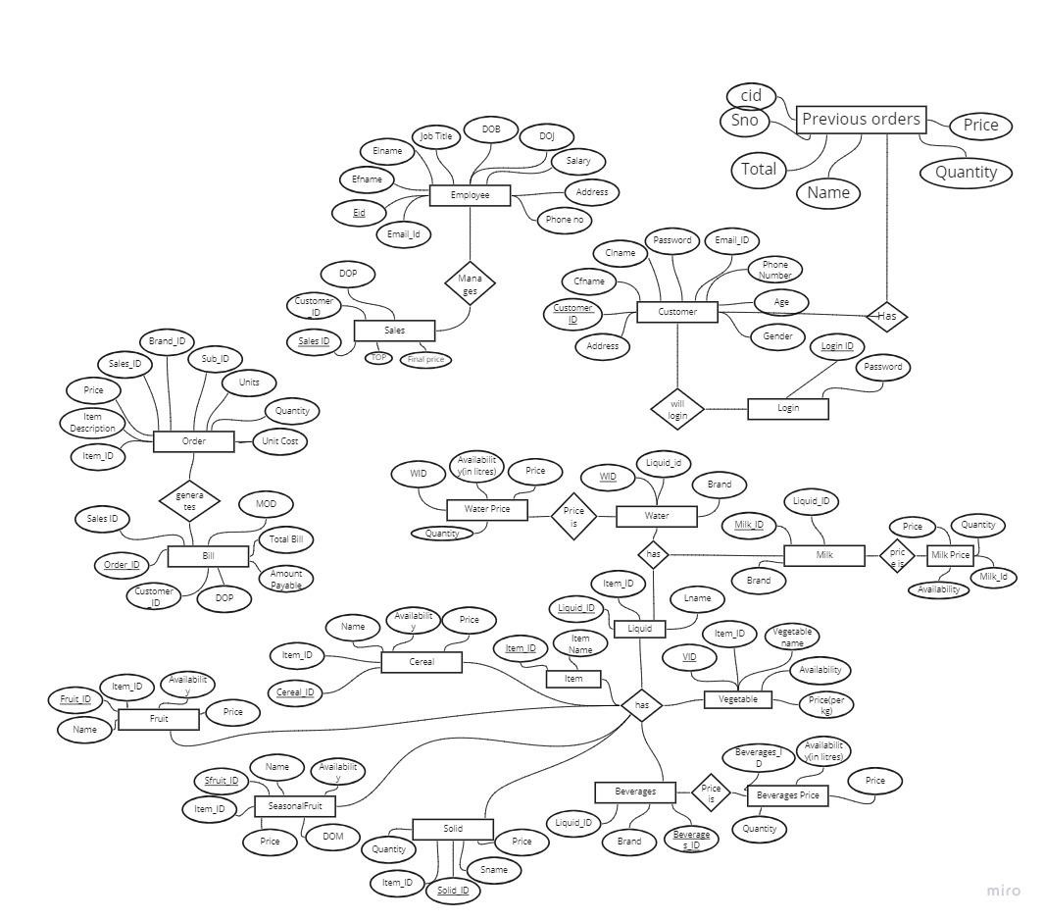

## Java-SQL Connectivity using JDBC

Java Database Connectivity (JDBC) is an application programming interface (API) for the programming language Java, which defines how a client may access a database. It is a Java-based data access technology used for Java database connectivity. It is part of the Java Standard Edition platform, from Oracle Corporation. It provides methods to query and update data in a database and is oriented towards relational databases.

## JDBC Connectivity

private void connToDb(){ try {

Class.forName(“oracle.jdbc.driver.OracleDriver”); connection =

DriverManager.getConnection("jdbc:oracle:thin:@localhost:1522:xe","tilakavati","tilak

");

statement = connection.createStatement();

} catch (SQLException connectException) {

System.out.println(connectException.getMessage());

System.out.println(connectException.getSQLState());

System.out.println(connectException.getErrorCode());

System.exit(1);

} catch (

Exception e)

{

System.err.println("Unable to find and load driver");

System.exit(1);

}}

Thus, the connection from Java to Oracle database is performed and therefore, can be used for updating tables in the database directly.

# IMPLEMENTATION

## Admin.java

package dbmsp; import java.awt.EventQueue; import javax.swing.JFrame; import javax.swing.JPanel; import javax.swing.border.EmptyBorder; import javax.swing.ImageIcon; import javax.swing.JButton; import java.awt.event.ActionListener; import java.awt.event.ActionEvent; import java.awt.Font; import javax.swing.JLabel; public class admin extends JFrame { public static boolean admin=false; public static boolean user1=false; private static final long serialVersionUID = 1L; private JPanel contentPane; public static void main(String[] args) {

EventQueue.invokeLater(new Runnable() { public void run() { try {

admin frame = new admin(); frame.setTitle("Grocery Store"); frame.setVisible(true);

} catch (Exception e) {

e.printStackTrace();

}

}

});

}

public admin() {

setDefaultCloseOperation(JFrame.EXIT_ON_CLOSE); setBounds(100, 100, 530, 342); contentPane = new JPanel();

contentPane.setBorder(new EmptyBorder(5, 5, 5, 5)); setContentPane(contentPane);

contentPane.setLayout(null);

JLabel lblNewLabel = new JLabel("New label"); lblNewLabel.setBounds(27, 11, 461, 281); contentPane.add(lblNewLabel);

ImageIcon icon = new ImageIcon(this.getClass().getResource("/supermarket-managementsystem.jpg"));

lblNewLabel.setIcon(icon);

JButton btnNewButton = new JButton("Admin"); btnNewButton.setFont(new Font("Tahoma", Font.BOLD, 11)); btnNewButton.addActionListener(new ActionListener() { public void actionPerformed(ActionEvent e) {

admin=true;

login.adminloginscreen(); if(login.flag==true) { insadmin.adminscreen();

}

}

});

btnNewButton.setBounds(190, 52, 111, 37); contentPane.add(btnNewButton);

JButton btnNewButton_1 = new JButton("User"); btnNewButton_1.setFont(new Font("Tahoma", Font.BOLD, 11)); btnNewButton_1.addActionListener(new ActionListener() { public void actionPerformed(ActionEvent e) {

user1=true;

user.userscreen();

}

});

btnNewButton_1.setBounds(190, 117, 111, 37); contentPane.add(btnNewButton_1);

}

}

## Login.java

package dbmsp; import java.awt.Component; import java.awt.EventQueue; import javax.swing.JFrame; import javax.swing.JPanel; import javax.swing.border.EmptyBorder; import javax.swing.JLabel; import javax.swing.JOptionPane; import java.awt.Font; import javax.swing.JTextField; import javax.swing.JPasswordField; import javax.swing.JButton; import java.awt.event.ActionListener; import java.sql.Connection; import java.sql.DriverManager; import java.sql.PreparedStatement; import java.sql.ResultSet; import java.sql.SQLException; import java.awt.event.ActionEvent; import java.awt.Color; import javax.swing.UIManager; public class login extends JFrame { public static boolean flag=false; private static final long serialVersionUID = 1L; private JPanel contentPane;

private JTextField textField; private JPasswordField passwordField; protected Component frame; String a,b; public static int cid; public static int di;

static login frame1; static String name="";

public static void adminloginscreen() {

EventQueue.invokeLater(new Runnable() { public void run() {

try {

login frame = new login(); frame.setTitle("Grocery Store"); frame.setVisible(true);

} catch (Exception e) {

e.printStackTrace();

}

}

});

}

public login() {

dispose();

setBounds(100, 100, 601, 353); contentPane = new JPanel();

contentPane.setBackground(UIManager.getColor("InternalFrame.resizeIconHighlight")); contentPane.setBorder(new EmptyBorder(5, 5, 5, 5)); setContentPane(contentPane); contentPane.setLayout(null); if(usersc.s==1) { dispose();

}

JLabel lblNewLabel = new JLabel("Username"); lblNewLabel.setFont(new Font("Tahoma", Font.PLAIN, 20)); lblNewLabel.setBounds(77, 59, 102, 34);

contentPane.add(lblNewLabel);

JLabel lblNewLabel_1 = new JLabel("Password"); lblNewLabel_1.setFont(new Font("Tahoma", Font.PLAIN, 20));

lblNewLabel_1.setBounds(77, 146, 102, 34);

contentPane.add(lblNewLabel_1);

textField = new JTextField(); textField.setBounds(263, 63, 161, 34); contentPane.add(textField); textField.setColumns(10);

passwordField = new JPasswordField(); passwordField.setBounds(263, 146, 161, 34); contentPane.add(passwordField); JButton btnNewButton = new JButton("Login");

btnNewButton.setBackground(UIManager.getColor("Button.disabledShadow")); btnNewButton.setForeground(new Color(0, 0, 0)); btnNewButton.addActionListener(new ActionListener() { public void actionPerformed(ActionEvent e) { String s=textField.getText(); char[] p=passwordField.getPassword(); String pass=String.valueOf(p); if(admin.admin==true) {

if(pass.equals("") && s.trim().equals("")) {

JOptionPane.showMessageDialog(frame,"Please fill out the username and password fields");

}

else if(pass.equals("") && s.length()>0) {

JOptionPane.showMessageDialog(frame, "Please fill out the password field");

}

else if(pass.length()>0 && s.length()==0) {

JOptionPane.showMessageDialog(frame, "Please fill out the user field");

}

elseif(s.trim().equals("admin")&& pass.trim().equals("admin@123")) {

setDefaultCloseOperation(JFrame.DISPOSE_ON_CLOSE);

dispose(); flag=true;

insadmin.adminscreen(); admin.admin=false; flag=false;

}

else {

JOptionPane.showMessageDialog(frame,"incorrect username or password");

}

}

else { try {

String query="select * from grlogin where username=?";

Class.forName("oracle.jdbc.driver.OracleDriver");

Connection

con=DriverManager.getConnection("jdbc:oracle:thin:@localhost:1521:xe","tilakavati","tilak");

PreparedStatement ps=con.prepareStatement(query); ps.setString(1, textField.getText());

ResultSet rs=ps.executeQuery(); rs.next();

a=rs.getString(1); b=rs.getString(2); cid=rs.getInt(3); name=a;

}

catch(ClassNotFoundException|SQLException e1) { e1.printStackTrace();

}

if(pass.equals("") && s.trim().equals("")) {

JOptionPane.showMessageDialog(frame,"Please fill out the username and password fields");

}

else if(pass.equals("") && s.length()>0) {

JOptionPane.showMessageDialog(frame, "Please fill out the password field");

}

else if(pass.length()>0 && s.length()==0) {

JOptionPane.showMessageDialog(frame, "Please fill out the user field");

}

else if(s.equals(a) && pass.equals(b)) {

JOptionPane.showMessageDialog(frame,"Hurray! You have made it"); admin.user1=false;

usersc.screen(); dispose();

setVisible(false);

di=cid;

}

else {

JOptionPane.showMessageDialog(frame,"incorrect username or password");

}

}

}

});

btnNewButton.setBounds(107, 235, 134, 40); contentPane.add(btnNewButton);

JButton btnNewButton_1 = new JButton("Clear");

btnNewButton_1.setBackground(UIManager.getColor("Button.disabledShadow")); btnNewButton_1.addActionListener(new ActionListener() { public void actionPerformed(ActionEvent e) { textField.setText("");

passwordField.setText("");

}

});

btnNewButton_1.setBounds(337, 235, 134, 40); contentPane.add(btnNewButton_1);

}

}

## Logsc.java

package dbmsp; import java.awt.Component; import java.awt.EventQueue; import java.awt.Font; import java.awt.event.ActionEvent; import java.awt.event.ActionListener; import java.sql.Connection; import java.sql.DriverManager; import java.sql.PreparedStatement; import java.sql.SQLException; import javax.swing.JButton; import javax.swing.JFrame; import javax.swing.JLabel; import javax.swing.JOptionPane; import javax.swing.JPanel; import javax.swing.JPasswordField; import javax.swing.JTextField; import javax.swing.border.EmptyBorder; public class logsc extends JFrame { private static final long serialVersionUID = 1L;

//reg rg=new reg(); private JPanel contentPane; private JTextField textField; private JPasswordField passwordField; private JPasswordField passwordField_1; public static int logintext; Component frame=null; public static boolean suc=false; public static void screen() { EventQueue.invokeLater(new Runnable() { public void run() {

try {

logsc frame = new logsc(); frame.setTitle("Password Confirmation"); frame.setVisible(true);

} catch (Exception e) {

e.printStackTrace();

}

}

});

}

public logsc() {

setBounds(100, 100, 599, 384); contentPane = new JPanel();

contentPane.setBorder(new EmptyBorder(5, 5, 5, 5)); setContentPane(contentPane); contentPane.setLayout(null);

JLabel lblNewLabel = new JLabel("UserName"); lblNewLabel.setFont(new Font("Tahoma", Font.PLAIN, 14)); lblNewLabel.setBounds(65, 60, 108, 36);

contentPane.add(lblNewLabel);

JLabel lblNewLabel_1 = new JLabel("Password"); lblNewLabel_1.setFont(new Font("Tahoma", Font.PLAIN, 14)); lblNewLabel_1.setBounds(65, 127, 108, 36);

contentPane.add(lblNewLabel_1); textField = new JTextField(); textField.setBounds(265, 60, 145, 36); contentPane.add(textField);

textField.setColumns(10);

JLabel lblNewLabel_2 = new JLabel("Confirm Password"); lblNewLabel_2.setFont(new Font("Tahoma", Font.PLAIN, 14)); lblNewLabel_2.setBounds(65, 199, 110, 36); contentPane.add(lblNewLabel_2); JButton btnNewButton = new JButton("Save"); btnNewButton.addActionListener(new ActionListener() { public void actionPerformed(ActionEvent e) {

try {

String query1="select * from customer where cfname=?";

Class.forName("oracle.jdbc.driver.OracleDriver");

Connection con1=DriverManager.getConnection("jdbc:oracle:thin:@localhost:1521:xe","tilakavati","tilak");

PreparedStatement ps1=con1.prepareStatement(query1); ps1.setString(1, textField.getText()); ps1.executeUpdate();

String p1=String.valueOf(passwordField.getPassword()); String p2=String.valueOf(passwordField_1.getPassword());

if(p1.length()<8) {

Component frame = null;

JOptionPane.showMessageDialog(frame, "passwords must be 8 character long");

}

else if(p1.compareTo(p2)!=0 || p1.length()<8) {

Component frame = null;

JOptionPane.showMessageDialog(frame, "passwords must match");

}

else if(p1.compareTo(p2)==0 && p1.length()>=8){

String query="insert into grlogin values(?,?,?)";

Class.forName("oracle.jdbc.driver.OracleDriver");

Connection

con=DriverManager.getConnection("jdbc:oracle:thin:@localhost:1521:xe","tilakavati","tilak");

PreparedStatement ps=con.prepareStatement(query); ps.setString(1,textField.getText());

ps.setString(2,String.valueOf(passwordField.getPassword()));

ps.setInt(3, register.id);

suc=true;

ps.executeUpdate(); dispose();

setVisible(false); ps.close();

con.close();

}

}

catch (ClassNotFoundException e1) { // TODO Auto-generated catch block e1.printStackTrace();

} catch (SQLException e1) {

// TODO Auto-generated catch block

//e1.printStackTrace();

JOptionPane.showMessageDialog(null,"Username already exists","Error message" ,JOptionPane.ERROR_MESSAGE);

}}

});

btnNewButton.setBounds(84, 274, 126, 36); contentPane.add(btnNewButton);

JButton btnNewButton_1 = new JButton("Clear"); btnNewButton_1.addActionListener(new ActionListener() { public void actionPerformed(ActionEvent e) { passwordField.setText(""); passwordField_1.setText("")

};

});

btnNewButton_1.setBounds(251, 274, 116, 36); contentPane.add(btnNewButton_1);

JButton btnNewButton_2 = new JButton("Back"); btnNewButton_2.addActionListener(new ActionListener() { public void actionPerformed(ActionEvent e) {

dispose();

setVisible(false);}

});

btnNewButton_2.setBounds(407, 274, 116, 36); contentPane.add(btnNewButton_2);

passwordField = new JPasswordField(); passwordField.setBounds(265, 129, 145, 36); contentPane.add(passwordField); passwordField_1 = new JPasswordField(); passwordField_1.setBounds(265, 201, 145, 36); contentPane.add(passwordField_1);

}}

## Additems.java

package dbmsp; import java.awt.Component; import java.awt.EventQueue; import javax.swing.JFrame; import javax.swing.JPanel; import javax.swing.border.EmptyBorder; import javax.swing.table.DefaultTableModel; import javax.swing.JTextField; import javax.swing.JLabel; import javax.swing.JOptionPane; import javax.swing.JComboBox; import java.awt.Font; import javax.swing.JButton; import java.awt.event.ActionListener; import java.sql.Connection; import java.sql.DriverManager; import java.sql.PreparedStatement; import java.sql.ResultSet;

import java.sql.SQLException; import java.sql.Statement; import java.awt.event.ActionEvent; import java.awt.event.ItemListener; import java.awt.event.ItemEvent; public class additems extends JFrame {

private static final long serialVersionUID = 1L; private JPanel contentPane; private JTextField textField; private JTextField textField_1; private JTextField textField_2;

String cat[]= {"Select","Vegetables","Water","Milk","Beverages","Solid","Fruits","Seasonal

Fruits","Cereals"}; public static int n,b,c;

DefaultTableModel model; Component frame=null; private JTextField textField_3; public static void screen() {

EventQueue.invokeLater(new Runnable() { public void run() {

try {

additems frame = new additems(); frame.setTitle("Items Info"); frame.setVisible(true);

} catch (Exception e) {

e.printStackTrace();

}

}

});

}

public additems() {

dispose();

setBounds(100, 100, 575, 409);

contentPane = new JPanel();

contentPane.setBorder(new EmptyBorder(5, 5, 5, 5)); setContentPane(contentPane); contentPane.setLayout(null); model=new DefaultTableModel(); textField = new JTextField();

textField.setBounds(158, 45, 86, 20); contentPane.add(textField); textField.setColumns(10); JLabel lblNewLabel = new JLabel("Name"); lblNewLabel.setFont(new Font("Tahoma", Font.PLAIN, 14)); lblNewLabel.setBounds(30, 43, 86, 20); contentPane.add(lblNewLabel); textField_1 = new JTextField(); textField_1.setBounds(158, 91, 86, 20); contentPane.add(textField_1); textField_1.setColumns(10);

JLabel lblNewLabel_1 = new JLabel("Quantity"); lblNewLabel_1.setFont(new Font("Tahoma", Font.PLAIN, 14)); lblNewLabel_1.setBounds(30, 92, 86, 14); contentPane.add(lblNewLabel_1); textField_2 = new JTextField(); textField_2.setBounds(158, 145, 86, 20); contentPane.add(textField_2); textField_2.setColumns(10);

JLabel lblNewLabel_2 = new JLabel("Price"); lblNewLabel_2.setFont(new Font("Tahoma", Font.PLAIN, 14)); lblNewLabel_2.setBounds(30, 146, 46, 14); contentPane.add(lblNewLabel_2);

@SuppressWarnings({ "rawtypes", "unchecked" }) JComboBox comboBox = new JComboBox(cat); comboBox.addItemListener(new ItemListener() { public void itemStateChanged(ItemEvent e) { String d=(String) comboBox.getSelectedItem();

if(d.equals("Water")||d.equals("Beverages")||d.equals("Milk")){ textField_3.setEditable(true);

}

else {

textField_3.setEditable(false);

}

}

});

comboBox.addActionListener(new ActionListener() { public void actionPerformed(ActionEvent e) { String s=comboBox.getSelectedItem().toString(); if(s.equals("Beverages")||s.equals("Milk")||s.equals("Water")) {

textField_3.setEditable(true);

}

}

});

comboBox.setBounds(158, 256, 114, 22); contentPane.add(comboBox); comboBox.getSelectedItem().toString();

JLabel lblNewLabel_3 = new JLabel("Select Category"); lblNewLabel_3.setFont(new Font("Tahoma", Font.PLAIN, 14)); lblNewLabel_3.setBounds(30, 255, 125, 21); contentPane.add(lblNewLabel_3);

if(comboBox.getSelectedItem().toString().equals("Beverages")) { textField_3.setEditable(true);

}

JButton btnNewButton = new JButton("Save"); btnNewButton.addActionListener(new ActionListener() { public void actionPerformed(ActionEvent e) {

if(textField.getText().length()<2||textField_1.getText().length()<1||textField_2.getText().length()<1) {

JOptionPane.showMessageDialog(frame, "Please fill the boxes");

}

else if(comboBox.getSelectedIndex()==0) {

JOptionPane.showMessageDialog(frame, "Please select the cateogry");

} else {

int a=JOptionPane.showConfirmDialog(frame,"Are you sure you want to save");

if(a==JOptionPane.YES_OPTION) {

JOptionPane.showMessageDialog(frame,"Saved");

try {

Class.forName("oracle.jdbc.driver.OracleDriver");

Connection

con=DriverManager.getConnection("jdbc:oracle:thin:@localhost:1521:xe","tilakavati","tilak");

String d=comboBox.getSelectedItem().toString(); if(d.equals("Vegetables")) { textField_3.setEditable(false);

String query1="insert into vegetable values(seq_veg.nextval,?,?,?,?)"; PreparedStatement ps1=con.prepareStatement(query1);

ps1.setInt(1, 1);

ps1.setString(2, textField.getText()); ps1.setInt(3,n); ps1.setInt(4, b); ps1.executeUpdate();

}

if(d.equals("Water")) {

try {

n=Integer.parseInt(textField_1.getText()); b=Integer.parseInt(textField_2.getText()); c=Integer.parseInt(textField_3.getText());

}

catch(NumberFormatException e1) {

JOptionPane.showMessageDialog(frame, "Quantity and price should be numbers");

}

String query5="select * from water where brand=?"; PreparedStatement ps5=con.prepareStatement(query5); ps5.setString(1, textField.getText()); int u=ps5.executeUpdate();

ResultSet rs=ps5.executeQuery();

if(u==0) {

String query2="insert into water values(seq_wat.nextval,?,?)"; PreparedStatement ps2=con.prepareStatement(query2);

ps2.setInt(1,2);

ps2.setString(2,textField.getText()); ps2.executeUpdate();

String query4="select max(wid) from water";

Statement ps3=con.createStatement(); ResultSet rs1=ps3.executeQuery(query4);

rs1.next();

int y=rs1.getInt(1);

String query3="insert into waterap values(?,?,?,?)"; PreparedStatement ps4=con.prepareStatement(query3);

ps4.setInt(1, y); ps4.setInt(2, c); ps4.setInt(3, b); ps4.setInt(4,n); ps4.execute();

}

if(u>=1) { rs.next();

int wid=rs.getInt(1);

String query3="insert into waterap values(?,?,?,?)";

PreparedStatement ps4=con.prepareStatement(query3); ps4.setInt(1, wid); ps4.setInt(2, c);

ps4.setInt(3, b); ps4.setInt(4,n); ps4.execute();

}

}

if(d.equals("Milk")) {

try {

n=Integer.parseInt(textField_1.getText()); b=Integer.parseInt(textField_2.getText()); c=Integer.parseInt(textField_3.getText());

}

catch(NumberFormatException e1) {

JOptionPane.showMessageDialog(frame, "Quantity and price should be numbers");

}

String query5="select * from milk where brand=?"; PreparedStatement ps5=con.prepareStatement(query5);

ps5.setString(1, textField.getText()); int u=ps5.executeUpdate(); ResultSet rs=ps5.executeQuery(); if(u==0) {

String query2="insert into milk values(seq_milk.nextval,?,?)"; PreparedStatement ps2=con.prepareStatement(query2); ps2.setInt(1,7);

ps2.setString(2,textField.getText()); ps2.executeUpdate(); ps2.close();

String query4="select max(milk_id) from milk";

Statement ps3=con.createStatement();

ResultSet rs1=ps3.executeQuery(query4); rs1.next();

int y=rs1.getInt(1);

String query3="insert into milkap values(?,?,?,?)";

PreparedStatement ps4=con.prepareStatement(query3);

ps4.setInt(1, y); ps4.setInt(2, c); ps4.setInt(3, b); ps4.setInt(4,n);

ps4.execute();

}

else { rs.next();

int milkid=rs.getInt(1);

String query3="insert into milkap values(?,?,?,?)"; PreparedStatement ps4=con.prepareStatement(query3);

ps4.setInt(1, milkid); ps4.setInt(2, c); ps4.setInt(3, b); ps4.setInt(4,n); ps4.execute();

}

}

if(d.equals("Beverages")) { try {

n=Integer.parseInt(textField_1.getText()); b=Integer.parseInt(textField_2.getText()); c=Integer.parseInt(textField_3.getText());

}

catch(NumberFormatException e1) {

JOptionPane.showMessageDialog(frame, "Quantity and price should be numbers");

}

String query5="select * from beverages where brand=?";

PreparedStatement ps5=con.prepareStatement(query5);

ps5.setString(1, textField.getText()); int u=ps5.executeUpdate(); ResultSet rs=ps5.executeQuery();

if(u==0) {

String query2="insert into beverages values(seq_bevr.nextval,?,?)";

PreparedStatement ps2=con.prepareStatement(query2);

ps2.setInt(1,8);

ps2.setString(2,textField.getText()); ps2.executeUpdate(); ps2.close();

String query4="select max(beverages_id) from beverages";

Statement ps3=con.createStatement(); ResultSet rs1=ps3.executeQuery(query4);

rs1.next();

int y=rs1.getInt(1);

String query3="insert into beveragesap values(?,?,?,?)";

PreparedStatement ps4=con.prepareStatement(query3);

ps4.setInt(1, y); ps4.setInt(2, c); ps4.setInt(3, b); ps4.setInt(4,n); ps4.execute(); ps2.close(); ps3.close(); ps4.close(); ps5.close(); }else { rs.next();

int bevid=rs.getInt(1);

String query3="insert into beveragesap values(?,?,?,?)";

PreparedStatement ps4=con.prepareStatement(query3);

ps4.setInt(1, bevid);

ps4.setInt(2, c); ps4.setInt(3, b);

ps4.setInt(4,n); ps4.execute(); ps4.close();

}

}

if(d.equals("Solid")) { textField_3.setEditable(false);

try {

n=Integer.parseInt(textField_1.getText()); b=Integer.parseInt(textField_2.getText());

}

catch(NumberFormatException e1) {

JOptionPane.showMessageDialog(frame, "Quantity and price should be numbers");

}

String query1="insert into solid values(seq_solid.nextval,?,?,?,?)"; PreparedStatement ps1=con.prepareStatement(query1); ps1.setInt(1, 3);

ps1.setString(2, textField.getText()); ps1.setInt(3,n); ps1.setInt(4, b); ps1.executeUpdate();

}

if(d.equals("Fruits")) { textField_3.setEditable(false); try {

n=Integer.parseInt(textField_1.getText()); b=Integer.parseInt(textField_2.getText()); }

catch(NumberFormatException e1) {

JOptionPane.showMessageDialog(frame, "Quantity and price should be numbers");

}

String query1="insert into fruit values(seq_fruit.nextval,?,?,?,?)"; PreparedStatement ps1=con.prepareStatement(query1);

ps1.setInt(1, 4);

ps1.setString(2, textField.getText());

ps1.setInt(3,n); ps1.setInt(4, b); ps1.executeUpdate();

}

if(d.equals("Seasonal Fruits")) { textField_3.setEditable(false);

try {

n=Integer.parseInt(textField_1.getText()); b=Integer.parseInt(textField_2.getText());

}

catch(NumberFormatException e1) {

JOptionPane.showMessageDialog(frame, "Quantity and price should be numbers");

}

java.util.Date date1 = new java.util.Date(); long t = date1.getTime(); java.sql.Date sqlDate = new java.sql.Date(t);

String query1="insert into seasonalfruit values(seq_sfruit.nextval,?,?,?,?,?)"; PreparedStatement ps1=con.prepareStatement(query1);

ps1.setInt(1, 5);

ps1.setString(2, textField.getText()); ps1.setInt(3,n); ps1.setInt(4, b); ps1.setDate(5, sqlDate); ps1.executeUpdate();

}

if(d.equals("Cereals")) {

textField_3.setEditable(false);

try {

n=Integer.parseInt(textField_1.getText());

b=Integer.parseInt(textField_2.getText());

}

catch(NumberFormatException e1) {

JOptionPane.showMessageDialog(frame, "Quantity and price should be numbers");

}

String query1="insert into cereal values(seq_cereal.nextval,?,?,?,?)"; PreparedStatement ps1=con.prepareStatement(query1);

ps1.setInt(1, 6);

ps1.setString(2, textField.getText());

ps1.setInt(3,n); ps1.setInt(4, b); ps1.executeUpdate();

}

}

catch(ClassNotFoundException|SQLException e1 ) { e1.printStackTrace();

}

textField_3.setEditable(false); textField_3.setText("");

}

}

}

});

btnNewButton.setBounds(354, 44, 89, 23);

contentPane.add(btnNewButton);

JButton btnNewButton_1 = new JButton("Clear"); btnNewButton_1.addActionListener(new ActionListener() { public void actionPerformed(ActionEvent e) { textField.setText("");

textField_1.setText(""); textField_2.setText(""); textField_3.setText(""); textField_3.setEditable(false); comboBox.setSelectedIndex(0);

}

});

btnNewButton_1.setBounds(354, 103, 89, 23); contentPane.add(btnNewButton_1);

JButton btnNewButton_2 = new JButton("Delete"); btnNewButton_2.addActionListener(new ActionListener() { public void actionPerformed(ActionEvent e) {

textField_1.setText(""); textField_2.setText(""); textField_3.setText(""); textField_1.setEditable(false); textField_2.setEditable(false); textField_3.setEditable(false);

if(textField.getText().length()>2 && comboBox.getSelectedItem()!="Select") { int a=JOptionPane.showConfirmDialog(frame,"Are you sure you want to delete");

if(a==JOptionPane.YES_OPTION) {

try {

String a1=textField.getText();

String f=comboBox.getSelectedItem().toString(); if(f.equals("Vegetables")) {

String query="delete from vegetable where vegetable_name=?";

Class.forName("oracle.jdbc.driver.OracleDriver");

Connection

con=DriverManager.getConnection("jdbc:oracle:thin:@localhost:1521:xe","tilakavati","tilak");

PreparedStatement ps=con.prepareStatement(query);

ps.setString(1,a1); int y=ps.executeUpdate();

if(y==0) {

JOptionPane.showMessageDialog(frame, "Item name doesnt exist");

}

else {

JOptionPane.showMessageDialog(frame,"Deleted");

}

System.out.println(y);

}

if(f.equals("Water")) {

String query="delete from water where brand=?";

String query1="select wid from water where brand=?";

Class.forName("oracle.jdbc.driver.OracleDriver");

Connection

con=DriverManager.getConnection("jdbc:oracle:thin:@localhost:1521:xe","tilakavati","tilak");

PreparedStatement ps=con.prepareStatement(query); PreparedStatement ps1=con.prepareStatement(query1);

ps.setString(1,a1); ps1.setString(1,a1);

ResultSet rs=ps1.executeQuery();

if(rs==null) {

JOptionPane.showMessageDialog(frame, "Item name doesnt exist");

}

else {

rs.next(); int s=rs.getInt(1);

String query2="delete from waterap where wid=?";

PreparedStatement ps2=con.prepareStatement(query2);

ps2.setInt(1, s); int h=ps2.executeUpdate();

System.out.println(h);

if(h==1) {

JOptionPane.showMessageDialog(frame,"Deleted");

}

}

}

if(f.equals("Milk")) {

String query="delete from milk where brand=?";

Class.forName("oracle.jdbc.driver.OracleDriver");

Connection

con=DriverManager.getConnection("jdbc:oracle:thin:@localhost:1521:xe","tilakavati","tilak");

PreparedStatement ps=con.prepareStatement(query);

ps.setString(1,a1); int y=ps.executeUpdate();

if(y==0) {

JOptionPane.showMessageDialog(frame, "Item name doesnt exist");

}

else {

JOptionPane.showMessageDialog(frame,"Deleted");

}

}

if(f.equals("Beverages")) {

String query="delete from beverages where brand=?";

Class.forName("oracle.jdbc.driver.OracleDriver");

Connection

con=DriverManager.getConnection("jdbc:oracle:thin:@localhost:1521:xe","tilakavati","tilak"); PreparedStatement ps=con.prepareStatement(query); ps.setString(1,a1);

int y=ps.executeUpdate();

if(y==0) {

JOptionPane.showMessageDialog(frame, "Item name doesnt exist");

}else {

JOptionPane.showMessageDialog(frame,"Deleted");

}

}

if(f.equals("Solid")) {

String query="delete from solid where sname=?";

Class.forName("oracle.jdbc.driver.OracleDriver");

Connection

con=DriverManager.getConnection("jdbc:oracle:thin:@localhost:1521:xe","tilakavati","tilak");

PreparedStatement ps=con.prepareStatement(query);

ps.setString(1,a1); int y=ps.executeUpdate();

if(y==0) {

JOptionPane.showMessageDialog(frame, "Item name doesnt exist");

}else {

JOptionPane.showMessageDialog(frame,"Deleted");

} }

if(f.equals("Fruits")) {

String query="delete from fruit where name=?";

Class.forName("oracle.jdbc.driver.OracleDriver");

Connection

con=DriverManager.getConnection("jdbc:oracle:thin:@localhost:1521:xe","tilakavati","tilak");

PreparedStatement ps=con.prepareStatement(query);

ps.setString(1,a1); int y=ps.executeUpdate();

if(y==0) {

JOptionPane.showMessageDialog(frame, "Item name doesnt exist");

}else {

JOptionPane.showMessageDialog(frame,"Deleted");

}

}

if(f.equals("Seasonal Fruits")){

String query="delete from seasonalfruit where name=?";

Class.forName("oracle.jdbc.driver.OracleDriver");

Connection

con=DriverManager.getConnection("jdbc:oracle:thin:@localhost:1521:xe","tilakavati","tilak");

PreparedStatement ps=con.prepareStatement(query);

ps.setString(1,a1); int y=ps.executeUpdate();

if(y==0) {

JOptionPane.showMessageDialog(frame, "Item name doesnt exist");

}else {

JOptionPane.showMessageDialog(frame,"Deleted");

}

}

if(f.equals("Cereals")) {

String query="delete from cereal where name=?";

Class.forName("oracle.jdbc.driver.OracleDriver");

Connection

con=DriverManager.getConnection("jdbc:oracle:thin:@localhost:1521:xe","tilakavati","tilak");

PreparedStatement ps=con.prepareStatement(query); ps.setString(1,a1); int y=ps.executeUpdate();

if(y==0) {

JOptionPane.showMessageDialog(frame, "Item name doesnt exist");

}else {

JOptionPane.showMessageDialog(frame,"Deleted");

}

}

}

catch(ClassNotFoundException |SQLException e2) {

e2.printStackTrace();

}

textField.setText(""); textField_1.setEditable(true); textField_2.setEditable(true); comboBox.setSelectedIndex(0);

}

else {

textField.setText(""); textField_1.setEditable(true); textField_2.setEditable(true); comboBox.setSelectedIndex(0);

}

}

else { JOptionPane.showMessageDialog(frame,"Write the name and select the category you want to delete");

}}

});

btnNewButton_2.setBounds(354, 166, 89, 23); contentPane.add(btnNewButton_2);

JButton btnNewButton_3 = new JButton("Back"); btnNewButton_3.addActionListener(new ActionListener() { public void actionPerformed(ActionEvent e) {

dispose(); }

});

btnNewButton_3.setBounds(354, 228, 89, 23); contentPane.add(btnNewButton_3);

JLabel lblAvailability = new JLabel("Availability"); lblAvailability.setFont(new Font("Tahoma", Font.PLAIN, 14)); lblAvailability.setBounds(30, 205, 86, 20); contentPane.add(lblAvailability);

textField_3 = new JTextField(); textField_3.setColumns(10); textField_3.setBounds(158, 207, 86, 20); contentPane.add(textField_3);

textField_3.setEditable(false);

}

}

## Items.java

package dbmsp; import java.awt.Component; import java.awt.EventQueue; import javax.swing.JFrame; import javax.swing.JPanel; import javax.swing.border.EmptyBorder; import javax.swing.table.DefaultTableModel; import javax.swing.JComboBox; import java.awt.event.MouseAdapter; import java.awt.event.MouseEvent; import java.sql.Connection; import java.sql.DriverManager; import java.sql.PreparedStatement; import javax.swing.JTextField; import javax.swing.JLabel; import javax.swing.JOptionPane; import javax.swing.JButton; import java.awt.event.ActionListener; import java.awt.event.ActionEvent; import javax.swing.JTable; import javax.swing.JScrollPane; import java.sql.*; import java.awt.Font;

public class items extends JFrame {

private static final long serialVersionUID = 1L; private JPanel contentPane;

String s1[]={"Select","Vegetables","Water","Milk","Beverages","Solid","Fruits","Seasonal Fruits","Cereals"};

String veg[]={"Brinjal","Lady's finger","Tomato","Potato","Bottle Guard","Beans"};

String sol[]={"Cheese","Jaggery","Paneer","Bread","Rice","Pasta","Maggi"};

String fru[]={"Banana","Apple","Guava","Carrot","Kiwi","Plum"};

String sesfru[]={"Mango","Orange","Custard Apple","Sweet Lime"};

String cer[]={"Corn Flakes","Chocos","Oats","Honey Rings"};

String units[]= {"kg","g","L","ml","dozen","none"};

String cat[]={"SubCategory","niha"};

String milkb[]={"Amul","Jersey","Arogya"};

String waterb[]={"Oxygen","Bisleri","Kinley"};

String bevr[]={"Red Bull","Coca Cola","Sprite","Maaza","Sting","Flavored Milk"}; private JTextField textField; Component frame=null; private JTable table;

DefaultTableModel model; DefaultTableModel model1; private JTextField textField_1; private JTextField textField_2; private JScrollPane scrollPane;

@SuppressWarnings("rawtypes") JComboBox comboBox ; private JTable table_1; public static int id=0; public int sum=0;

public static void itemscreen() {

EventQueue.invokeLater(new Runnable() { public void run() {

try {

items frame = new items();

frame.setTitle(login.name);

frame.setVisible(true);

} catch (Exception e) {

e.printStackTrace();

}

}

});

}

@SuppressWarnings({ "unchecked", "rawtypes" }) public items() {

setDefaultCloseOperation(JFrame.EXIT_ON_CLOSE); setBounds(100, 100, 861, 707); contentPane = new JPanel();

contentPane.setBorder(new EmptyBorder(5, 5, 5, 5)); setContentPane(contentPane); contentPane.setLayout(null);

scrollPane = new JScrollPane(); scrollPane.setBounds(10, 345, 649, 312); contentPane.add(scrollPane);

scrollPane.addMouseListener(new MouseAdapter() {

@Override

public void mouseClicked(MouseEvent e) { int i=table.getSelectedRow();

textField_1.setText(model.getValueAt(i, 2).toString()); textField_2.setText(model.getValueAt(i, 4).toString());

}

});

JScrollPane scrollPane_1 = new JScrollPane(); scrollPane_1.setBounds(267, 41, 568, 226);

contentPane.add(scrollPane_1);

table_1 = new JTable(); model1=new DefaultTableModel();

Object t1[]= {"id","Item","price","quantity","total"}; Object r1[]=new Object[5]; model1.setColumnIdentifiers(t1); table_1.setModel(model1);

table_1.setDefaultEditor(Object.class,null); scrollPane_1.setViewportView(table_1); table = new JTable(); model=new DefaultTableModel();

table.setDefaultEditor(Object.class, null);

Object column1[]= {"vid","item_id","vegetable_name","availability","price"};

Object column2[]= {"wid","liquid_id","brand","availability","price","quantity"};

Object column3[]= {"milk_id","liquid_id","brand","availability","price","quantity"};

Object column4[]= {"beverages_id","liquid_id","brand","availability","price","quantity"};

Object column5[]= {"solid_id","item_id","sname","availability","price"};

Object column6[]= {"fruit_id","item_id","name","availability","price"};

Object column7[]= {"sfruit_id","item_id","name","availability","price","dom"};

Object column8[]= {"cereal_id","item_id","name","availability","price"};

Object row1[]=new Object[5];

Object row2[]=new Object[6];

Object row3[]=new Object[6];

Object row4[]=new Object[6];

Object row5[]=new Object[5];

Object row6[]=new Object[5];

Object row7[]=new Object[6]; Object row8[]=new Object[5]; table.setModel(model); scrollPane.setViewportView(table); comboBox = new JComboBox(s1);

comboBox.addActionListener(new ActionListener() { public void actionPerformed(ActionEvent e) { try {

String s=(String)comboBox.getSelectedItem(); if(s.equals("Vegetables")) { model.setColumnIdentifiers(column1); model.setRowCount(0);

String query="select * from vegetable";

Class.forName("oracle.jdbc.driver.OracleDriver");

Connection

con=DriverManager.getConnection("jdbc:oracle:thin:@localhost:1521:xe","tilakavati","tilak");

PreparedStatement ps=con.prepareStatement(query); ResultSet rs=ps.executeQuery(); while(rs.next()) { row1[0]=rs.getInt(1); row1[1]=rs.getInt(2); row1[2]=rs.getString(3); row1[3]=rs.getInt(4); row1[4]=rs.getInt(5); model.addRow(row1);

}

}

if(s.equals("Water")) {

model.setColumnIdentifiers(column2); model.setRowCount(0);

String query=" select * from water natural join waterap order by wid,availability,quantity,price";

Class.forName("oracle.jdbc.driver.OracleDriver");

Connection

con=DriverManager.getConnection("jdbc:oracle:thin:@localhost:1521:xe","tilakavati","tilak");

PreparedStatement ps=con.prepareStatement(query); ResultSet rs=ps.executeQuery(); while(rs.next()) { row2[0]=rs.getInt(1); row2[1]=rs.getInt(2); row2[2]=rs.getString(3);

row2[3]=rs.getInt(4); row2[4]=rs.getInt(5); row2[5]=rs.getInt(6); model.addRow(row2);

} }

if(s.equals("Milk")) {

model.setColumnIdentifiers(column3); model.setRowCount(0);

String query=" select * from milk natural join milkap order by milk_id,availability,quantity,price";

Class.forName("oracle.jdbc.driver.OracleDriver");

Connection

con=DriverManager.getConnection("jdbc:oracle:thin:@localhost:1521:xe","tilakavati","tilak");

PreparedStatement ps=con.prepareStatement(query); ResultSet rs=ps.executeQuery(); while(rs.next()) { row3[0]=rs.getInt(1); row3[1]=rs.getInt(2); row3[2]=rs.getString(3); row3[3]=rs.getInt(4); row3[4]=rs.getInt(5); row3[5]=rs.getInt(6); model.addRow(row3);

}

}

if(s.equals("Beverages")) { model.setColumnIdentifiers(column4); model.setRowCount(0);

String query=" select * from beverages natural join beveragesap order by beverages_id,availability,quantity,price";

Class.forName("oracle.jdbc.driver.OracleDriver");

Connection

con=DriverManager.getConnection("jdbc:oracle:thin:@localhost:1521:xe","tilakavati","tilak");

PreparedStatement ps=con.prepareStatement(query); ResultSet rs=ps.executeQuery(); while(rs.next()) { row4[0]=rs.getInt(1); row4[1]=rs.getInt(2); row4[2]=rs.getString(3); row4[3]=rs.getInt(4); row4[4]=rs.getInt(5); row4[5]=rs.getInt(6); model.addRow(row4);

}

}

if(s.equals("Solid")) { model.setColumnIdentifiers(column5); model.setRowCount(0);

String query="select * from solid";

Class.forName("oracle.jdbc.driver.OracleDriver");

Connection

con=DriverManager.getConnection("jdbc:oracle:thin:@localhost:1521:xe","tilakavati","tilak");

PreparedStatement ps=con.prepareStatement(query); ResultSet rs=ps.executeQuery(); while(rs.next()) { row5[0]=rs.getInt(1); row5[1]=rs.getInt(2); row5[2]=rs.getString(3); row5[3]=rs.getInt(4); row5[4]=rs.getInt(5); model.addRow(row5);

}

}

if(s.equals("Fruits")) {

model.setColumnIdentifiers(column6);

model.setRowCount(0);

String query="select * from fruit";

Class.forName("oracle.jdbc.driver.OracleDriver");

Connection

con=DriverManager.getConnection("jdbc:oracle:thin:@localhost:1521:xe","tilakavati","tilak");

PreparedStatement ps=con.prepareStatement(query); ResultSet rs=ps.executeQuery(); while(rs.next()) { row6[0]=rs.getInt(1); row6[1]=rs.getInt(2); row6[2]=rs.getString(3); row6[3]=rs.getInt(4); row6[4]=rs.getInt(5); model.addRow(row6);

}

}

if(s.equals("Seasonal Fruits")) { model.setColumnIdentifiers(column7); model.setRowCount(0);

String query="select * from seasonalfruit";

Class.forName("oracle.jdbc.driver.OracleDriver");

Connection

con=DriverManager.getConnection("jdbc:oracle:thin:@localhost:1521:xe","tilakavati","tilak");

PreparedStatement ps=con.prepareStatement(query); ResultSet rs=ps.executeQuery(); while(rs.next()) { row7[0]=rs.getInt(1); row7[1]=rs.getInt(2); row7[2]=rs.getString(3); row7[3]=rs.getInt(4); row7[4]=rs.getInt(5); row7[5]=rs.getDate(6); model.addRow(row7);

}

}

if(s.equals("Cereals")) {

model.setColumnIdentifiers(column8); model.setRowCount(0);

String query="select * from cereal";

Class.forName("oracle.jdbc.driver.OracleDriver");

Connection

con=DriverManager.getConnection("jdbc:oracle:thin:@localhost:1521:xe","tilakavati","tilak");

PreparedStatement ps=con.prepareStatement(query); ResultSet rs=ps.executeQuery(); while(rs.next()) { row8[0]=rs.getInt(1); row8[1]=rs.getInt(2); row8[2]=rs.getString(3); row8[3]=rs.getInt(4); row8[4]=rs.getInt(5); model.addRow(row8);

}

}

}

catch(SQLException|ClassNotFoundException e1) { e1.printStackTrace();}

} });

model1.setRowCount(0); comboBox.setToolTipText("Items"); comboBox.setBounds(50, 32, 116, 33); contentPane.add(comboBox); textField = new JTextField(); textField.setBounds(116, 227, 122, 33); contentPane.add(textField); textField.setColumns(10); JLabel lblNewLabel = new JLabel("Quantity"); lblNewLabel.setBounds(35, 232, 73, 23);

contentPane.add(lblNewLabel);

JButton btnNewButton = new JButton("Add To Bill"); btnNewButton.addActionListener(new ActionListener() { public void actionPerformed(ActionEvent e) {

if(comboBox.getSelectedIndex()==0) {

JOptionPane.showMessageDialog(frame, "Select any category");

}

else if(textField.getText().equals("")) {

JOptionPane.showMessageDialog(frame,"Please enter the quantity");

}

else if(textField.getText().length()!=0) {

try {

int y=++id;

String name= textField_1.getText(); int price=Integer.parseInt(textField_2.getText()); int quan=Integer.parseInt(textField.getText());

int tot=price*quan; try{

String query="insert into prevorder values(?,?,?,?,?,?)";

Class.forName("oracle.jdbc.driver.OracleDriver");

Connection

con=DriverManager.getConnection("jdbc:oracle:thin:@localhost:1521:xe","tilakavati","tilak");

PreparedStatement ps=con.prepareStatement(query); ps.setInt(1,login.cid ); ps.setInt(2, y); ps.setString(3,name); ps.setInt(4, price); ps.setInt(5, quan); ps.setInt(6, tot);

sum+=tot;

ps.executeUpdate();

}

catch(SQLException|ClassNotFoundException e1) { e1.printStackTrace();

}

r1[0]=y; r1[1]=name; r1[2]=price; r1[3]=quan; r1[4]=tot;

model1.addRow(r1);

}

catch(NumberFormatException e1) {

JOptionPane.showMessageDialog(frame,"Please enter a number");

}}

}

});

btnNewButton.setBounds(35, 289, 116, 39); contentPane.add(btnNewButton);

JButton btnNewButton_1 = new JButton("Clear"); btnNewButton_1.addActionListener(new ActionListener() { public void actionPerformed(ActionEvent e) { textField.setText(""); textField_1.setText(""); textField_2.setText(""); comboBox.setSelectedIndex(0);

}

});

btnNewButton_1.setBounds(187, 289, 116, 39); contentPane.add(btnNewButton_1);

JButton btnNewButton_1_1 = new JButton("Back"); btnNewButton_1_1.addActionListener(new ActionListener() {

public void actionPerformed(ActionEvent e) {

dispose();

}

});

btnNewButton_1_1.setBounds(338, 289, 116, 39); contentPane.add(btnNewButton_1_1);

JButton btnNewButton_2 = new JButton("Buy"); btnNewButton_2.addActionListener(new ActionListener() { public void actionPerformed(ActionEvent e) {

try {

String query="insert into sales values(seq_sales.nextval,?,sysdate,?,to_char(sysdate,'hh24:mi:ss'))";

Class.forName("oracle.jdbc.driver.OracleDriver");

Connection

con=DriverManager.getConnection("jdbc:oracle:thin:@localhost:1521:xe","tilakavati","tilak");

PreparedStatement ps=con.prepareStatement(query); ps.setInt(1,login.cid); ps.setInt(2,sum); ps.executeUpdate();

JOptionPane.showMessageDialog(null,"Your total is "+sum); dispose();

}

catch(SQLException|ClassNotFoundException e1) { e1.printStackTrace();

}

}

});

btnNewButton_2.setBounds(496, 287, 116, 42); contentPane.add(btnNewButton_2);

JLabel lblName = new JLabel("Item"); lblName.setBounds(35, 94, 40, 23);

contentPane.add(lblName);

textField_1 = new JTextField(); textField_1.setColumns(10); textField_1.setBounds(116, 89, 122, 33); contentPane.add(textField_1);

JLabel lblName_1 = new JLabel("Price"); lblName_1.setBounds(35, 164, 65, 23); contentPane.add(lblName_1);

textField_2 = new JTextField(); textField_2.setColumns(10); textField_2.setBounds(116, 159, 122, 33); contentPane.add(textField_2);

textField_1.setEditable(false); textField_2.setEditable(false); JLabel lblBilling = new JLabel("Bill"); lblBilling.setFont(new Font("Tahoma", Font.PLAIN, 20)); lblBilling.setBounds(550, 11, 139, 23); contentPane.add(lblBilling);

}

}

## Insadmin.java

package dbmsp;

import java.awt.EventQueue; import javax.swing.JFrame; import javax.swing.JPanel; import javax.swing.border.EmptyBorder; import javax.swing.JButton; import java.awt.event.ActionListener; import java.awt.event.ActionEvent; public class insadmin extends JFrame { private static final long serialVersionUID = 1L; private JPanel contentPane; public static void adminscreen() {

EventQueue.invokeLater(new Runnable() { public void run() {

try {

insadmin frame = new insadmin(); frame.setTitle("admin login"); frame.setVisible(true);

} catch (Exception e) {

e.printStackTrace();

}

}

});

}

public insadmin() {

//setDefaultCloseOperation(JFrame.DO_NOTHING_ON_CLOSE);

dispose();

setBounds(100, 100, 529, 378); contentPane = new JPanel();

contentPane.setBorder(new EmptyBorder(5, 5, 5, 5)); setContentPane(contentPane); contentPane.setLayout(null);

JButton btnNewButton = new JButton("Add Items");

btnNewButton.addActionListener(new ActionListener() { public void actionPerformed(ActionEvent e) { additems.screen();

}

});

btnNewButton.setBounds(164, 70, 140, 39); contentPane.add(btnNewButton);

JButton btnNewButton_1 = new JButton("Sales Report"); btnNewButton_1.addActionListener(new ActionListener() { public void actionPerformed(ActionEvent e) {

frame.framescreen();

}

});

btnNewButton_1.setBounds(164, 132, 140, 39); contentPane.add(btnNewButton_1);

JButton btnNewButton_2 = new JButton("Customer Details"); btnNewButton_2.addActionListener(new ActionListener() { public void actionPerformed(ActionEvent e) { cust.custscreen();

}

});

btnNewButton_2.setBounds(164, 193, 140, 39); contentPane.add(btnNewButton_2);

JButton btnNewButton_3 = new JButton("Logout"); btnNewButton_3.addActionListener(new ActionListener() { public void actionPerformed(ActionEvent e) {

if(usersc.am==1) {

dispose();

}

dispose();

}

});

btnNewButton_3.setBounds(164, 255, 140, 39);

contentPane.add(btnNewButton_3);

JButton btnNewButton_4 = new JButton("Employees"); btnNewButton_4.addActionListener(new ActionListener() { public void actionPerformed(ActionEvent e) {

vemp.screen();

}

});

btnNewButton_4.setBounds(164, 11, 140, 39); contentPane.add(btnNewButton_4);

}

}

## Cust.java

package dbmsp; import java.awt.EventQueue; import javax.swing.JFrame; import javax.swing.JPanel; import javax.swing.JScrollPane; import javax.swing.border.EmptyBorder; import javax.swing.table.DefaultTableModel; import javax.swing.JButton; import java.awt.event.ActionListener; import java.sql.Connection; import java.sql.DriverManager; import java.sql.PreparedStatement; import java.sql.ResultSet; import java.sql.SQLException;

import java.awt.event.ActionEvent; import javax.swing.JTable; import javax.swing.JLabel; import javax.swing.JOptionPane;

public class cust extends JFrame {

private static final long serialVersionUID = 1L; private JPanel contentPane; private JLabel lblNewLabel; private JTable table; DefaultTableModel model; public static void custscreen() {

EventQueue.invokeLater(new Runnable() { public void run() {

try {

cust frame = new cust(); frame.setTitle("Customer Details"); frame.setVisible(true);

} catch (Exception e) {

e.printStackTrace();

}

}

});

}

public cust() {

dispose();

setBounds(100, 100, 1170, 540); contentPane = new JPanel();

contentPane.setBorder(new EmptyBorder(5, 5, 5, 5)); setContentPane(contentPane); contentPane.setLayout(null);

JScrollPane scrollPane = new JScrollPane(); scrollPane.setBounds(241, 39, 903, 434); contentPane.add(scrollPane); table = new JTable(); model=new DefaultTableModel();

Object column[]= {"customer_id","first name","last

name","email_id","gender","age","Phone no","address"};

Object row[]=new Object[8]; model.setColumnIdentifiers(column); table.setModel(model);

table.getColumnModel().getColumn(3).setPreferredWidth(90); table.getColumnModel().getColumn(5).setPreferredWidth(3); table.getColumnModel().getColumn(7).setPreferredWidth(90); scrollPane.setViewportView(table);

JButton btnNewButton = new JButton("View Customer"); btnNewButton.addActionListener(new ActionListener() { public void actionPerformed(ActionEvent e) {

model.setRowCount(0);

String y=JOptionPane.showInputDialog(null,"Enter the customer id"); String query="select * from customer where customer_id=?";

try {

Class.forName("oracle.jdbc.driver.OracleDriver");

Connection

con=DriverManager.getConnection("jdbc:oracle:thin:@localhost:1521:xe","tilakavati","tilak");

PreparedStatement ps=con.prepareStatement(query); ps.setInt(1,Integer.parseInt(y)); ResultSet rs=ps.executeQuery();

if(rs.next()==false) {

JOptionPane.showMessageDialog(null, "No customer_id");

}

else {

row[0]=rs.getInt(1); row[1]=rs.getString(2); row[2]=rs.getString(3); row[3]=rs.getString(4); row[4]=rs.getString(5); row[5]=rs.getInt(6); row[6]=rs.getString(7); row[7]=rs.getString(8); model.addRow(row); ps.close();

}

}

catch(SQLException|ClassNotFoundException e11) {

e11.printStackTrace();

}

}

});

btnNewButton.setBounds(32, 39, 125, 35); contentPane.add(btnNewButton); table = new JTable();

JScrollPane jScrollPane = new JScrollPane(); jScrollPane.setViewportView(table);

JButton btnNewButton_1 = new JButton("View all customers"); btnNewButton_1.addActionListener(new ActionListener() { public void actionPerformed(ActionEvent e) { model.setRowCount(0);

String query="select * from customer";

try {

Class.forName("oracle.jdbc.driver.OracleDriver");

Connection

con=DriverManager.getConnection("jdbc:oracle:thin:@localhost:1521:xe","tilakavati","tilak");

PreparedStatement ps=con.prepareStatement(query); ResultSet rs1=ps.executeQuery(); while(rs1.next()) { row[0]=rs1.getInt(1); row[1]=rs1.getString(2); row[2]=rs1.getString(3); row[3]=rs1.getString(4); row[4]=rs1.getString(5); row[5]=rs1.getInt(6); row[6]=rs1.getString(7); row[7]=rs1.getString(8); model.addRow(row);

}

}

catch(SQLException|ClassNotFoundException e11) { e11.printStackTrace();

}}

});

btnNewButton_1.setBounds(32, 85, 148, 35); contentPane.add(btnNewButton_1);

lblNewLabel = new JLabel("Select to view the details of customer "); lblNewLabel.setBounds(47, 11, 315, 33); contentPane.add(lblNewLabel);

JButton btnNewButton_1_1 = new JButton("Back"); btnNewButton_1_1.addActionListener(new ActionListener() { public void actionPerformed(ActionEvent e) { dispose();

}

});

btnNewButton_1_1.setBounds(32, 131, 104, 35); contentPane.add(btnNewButton_1_1);

}

}

## Register.java

package dbmsp; import java.awt.EventQueue; import javax.swing.JFrame; import javax.swing.JPanel; import javax.swing.border.EmptyBorder; import javax.swing.JLabel; import javax.swing.JOptionPane; import javax.swing.JTextField; import javax.swing.JRadioButton; import javax.swing.JTextArea; import javax.swing.ButtonGroup; import javax.swing.JButton; import java.awt.Color; import java.awt.Component; import java.awt.Font; import java.awt.event.ActionListener; import java.awt.event.ActionEvent; import java.sql.*; public class register extends JFrame { private static final long serialVersionUID = 1L; private JPanel contentPane; private JTextField textField; private JLabel lblNewLabel_2; private JLabel lblNewLabel_3; private JLabel lblNewLabel_4; private JLabel lblNewLabel_5; private JLabel lblNewLabel_6; private JTextField textField_1; private JTextField textField_2; private JTextField textField_3; private JRadioButton rdbtnNewRadioButton; private JRadioButton rdbtnNewRadioButton_1; private JRadioButton rdbtnNewRadioButton_2; private JTextArea textArea; private JTextField textField_4;

private JButton btnNewButton; private JButton btnClear; private JLabel lblNewLabel_7;

ButtonGroup g1;

Component frame=null; public static String fn="";

public static int id; public static void registerscreen() {

EventQueue.invokeLater(new Runnable() { public void run() {

try {

register frame = new register(); frame.setTitle("User Registration Form"); frame.setVisible(true);

} catch (Exception e) {

e.printStackTrace();

} }

});

}

public register() {

g1=new ButtonGroup(); dispose();

setBounds(400, 400, 697, 465); contentPane = new JPanel();

contentPane.setBorder(new EmptyBorder(5, 5, 5, 5)); setContentPane(contentPane); contentPane.setLayout(null);

JLabel lblNewLabel = new JLabel("First Name"); lblNewLabel.setBounds(35, 53, 85, 25); contentPane.add(lblNewLabel);

textField = new JTextField(); textField.setBounds(187, 53, 115, 25); contentPane.add(textField);

textField.setColumns(10); JLabel lblNewLabel_1 = new JLabel("Last Name"); lblNewLabel_1.setBounds(35, 89, 85, 25); contentPane.add(lblNewLabel_1); lblNewLabel_2 = new JLabel("Email ID"); lblNewLabel_2.setBounds(35, 120, 85, 25); contentPane.add(lblNewLabel_2); lblNewLabel_3 = new JLabel("Gender"); lblNewLabel_3.setBounds(35, 156, 85, 25); contentPane.add(lblNewLabel_3); lblNewLabel_4 = new JLabel("Address"); lblNewLabel_4.setBounds(35, 192, 85, 25); contentPane.add(lblNewLabel_4); lblNewLabel_5 = new JLabel("Age"); lblNewLabel_5.setBounds(35, 259, 85, 25); contentPane.add(lblNewLabel_5); lblNewLabel_6 = new JLabel("Phone Number"); lblNewLabel_6.setBounds(35, 295, 85, 25); contentPane.add(lblNewLabel_6); textField_1 = new JTextField(); textField_1.setBounds(187, 89, 115, 25); contentPane.add(textField_1); textField_1.setColumns(10); textField_2 = new JTextField(); textField_2.setColumns(10); textField_2.setBounds(187, 125, 115, 25);

contentPane.add(textField_2); textField_3 = new JTextField(); textField_3.setColumns(10); textField_3.setBounds(187, 259, 115, 25);

contentPane.add(textField_3); rdbtnNewRadioButton = new JRadioButton("Male"); rdbtnNewRadioButton.setBounds(193, 157, 109, 23);

contentPane.add(rdbtnNewRadioButton); rdbtnNewRadioButton_1 = new JRadioButton("Female"); rdbtnNewRadioButton_1.setBounds(298, 157, 109, 23); contentPane.add(rdbtnNewRadioButton_1);

rdbtnNewRadioButton_2 = new JRadioButton("Others"); rdbtnNewRadioButton_2.setBounds(409, 157, 109, 23); contentPane.add(rdbtnNewRadioButton_2); g1.add(rdbtnNewRadioButton); g1.add(rdbtnNewRadioButton_1); g1.add(rdbtnNewRadioButton_2); textArea = new JTextArea(); textArea.setBounds(187, 192, 209, 51); contentPane.add(textArea); textField_4 = new JTextField(); textField_4.setColumns(10); textField_4.setBounds(187, 295, 115, 25); contentPane.add(textField_4); btnNewButton = new JButton("Save");

btnNewButton.addActionListener(new ActionListener() { public void actionPerformed(ActionEvent e) {

if(textField.getText().length()<3) {

JOptionPane.showMessageDialog(frame, "Please fill the first name field");

}

else if(textField_1.getText().length()<3) {

JOptionPane.showMessageDialog(frame, "Please fill the last name field");

}

else if(textField_2.getText().length()<3) {

JOptionPane.showMessageDialog(frame, "Please enter the emaild");

}

else if(g1.getSelection()==null) {

JOptionPane.showMessageDialog(frame, "Please select the gender");

}

else if(textArea.getText().length()<1) {

JOptionPane.showMessageDialog(frame, "Please fill the address field");

}

else if(textField_3.getText().length()<1) {

JOptionPane.showMessageDialog(frame, "Please fill age field");

}

else if(textField_4.getText().length()<3) {

JOptionPane.showMessageDialog(frame, "Please fill phone number field");

}

else {

String gender="";

if(rdbtnNewRadioButton.isSelected()) {

gender="male";

}

else if(rdbtnNewRadioButton_1.isSelected()) {

gender="female";

}

else {

gender="others";

}

dispose();

String query="insert into customer values(seq_cust.nextval,?,?,?,?,?,?,?)";

try {

Class.forName("oracle.jdbc.driver.OracleDriver");

Connection

con=DriverManager.getConnection("jdbc:oracle:thin:@localhost:1521:xe","tilakavati","tilak");

PreparedStatement ps=con.prepareStatement(query); ps.setString(1, textField.getText()); ps.setString(2, textField_1.getText()); ps.setString(3, textField_2.getText()); ps.setString(4, gender);

ps.setInt(5, Integer.parseInt(textField_3.getText()));

ps.setString(6, textField_4.getText()); ps.setString(7, textArea.getText());

ps.execute();

ps.close(); con.close();

fn=textField.getText();

String query1="select max(customer_id) from customer";

Connection

con1=DriverManager.getConnection("jdbc:oracle:thin:@localhost:1521:xe","tilakavati","tilak");

PreparedStatement ps1=con1.prepareStatement(query1); ResultSet rs=ps1.executeQuery();

rs.next();

id=rs.getInt(1); logsc.screen();

}

catch(ClassNotFoundException|SQLException e1 ) {

e1.printStackTrace();

}

}

}

});

btnNewButton.setBounds(133, 343, 95, 36); contentPane.add(btnNewButton); btnClear = new JButton("Clear");

btnClear.addActionListener(new ActionListener() { public void actionPerformed(ActionEvent e) { textField.setText(""); textField_1.setText(""); textField_2.setText(""); textField_3.setText(""); textField_4.setText(""); g1.clearSelection(); textArea.setText("");

}

});

btnClear.setBounds(334, 343, 102, 36); contentPane.add(btnClear);

lblNewLabel_7 = new JLabel("Register Form"); lblNewLabel_7.setFont(new Font("Tahoma", Font.PLAIN, 20)); lblNewLabel_7.setBackground(new Color(240, 240, 240)); lblNewLabel_7.setBounds(58, 8, 157, 34); contentPane.add(lblNewLabel_7);

}

}

## Cedit.java

package dbmsp; import java.awt.EventQueue; import java.sql.Connection; import java.sql.DriverManager; import java.sql.PreparedStatement; import java.sql.ResultSet; import java.sql.SQLException; import javax.swing.ButtonGroup; import javax.swing.JButton; import javax.swing.JFrame; import javax.swing.JLabel; import javax.swing.JOptionPane; import javax.swing.JPanel; import javax.swing.JRadioButton; import javax.swing.JTextArea; import javax.swing.JTextField; import javax.swing.border.EmptyBorder; import java.awt.event.ActionListener; import java.awt.event.ActionEvent; public class cedit extends JFrame { private static final long serialVersionUID = 1L; private JPanel contentPane; private JTextField textField; private JLabel lblNewLabel_2; private JLabel lblNewLabel_3; private JLabel lblNewLabel_4; private JLabel lblNewLabel_5; private JLabel lblNewLabel_6; private JTextField textField_1; private JTextField textField_2; private JTextField textField_3; private JRadioButton rdbtnNewRadioButton; private JRadioButton rdbtnNewRadioButton_1; private JRadioButton rdbtnNewRadioButton_2; private JTextArea textArea; private JTextField textField_4; ButtonGroup g1; private JButton btnNewButton_1; private JButton btnNewButton_2; public static void screen() {

EventQueue.invokeLater(new Runnable() { public void run() {

try {

cedit frame = new cedit(); frame.setTitle(login.name); frame.setVisible(true);

} catch (Exception e) {

e.printStackTrace();

}

}

}); } public cedit() {

g1=new ButtonGroup(); dispose();

setBounds(400, 400, 697, 465);

contentPane = new JPanel();

contentPane.setBorder(new EmptyBorder(5, 5, 5, 5)); setContentPane(contentPane); contentPane.setLayout(null);

JLabel lblNewLabel = new JLabel("First Name"); lblNewLabel.setBounds(35, 53, 85, 25);

contentPane.add(lblNewLabel);

textField = new JTextField(); textField.setBounds(187, 53, 115, 25); contentPane.add(textField); textField.setColumns(10);

JLabel lblNewLabel_1 = new JLabel("Last Name"); lblNewLabel_1.setBounds(35, 89, 85, 25); contentPane.add(lblNewLabel_1); lblNewLabel_2 = new JLabel("Email ID"); lblNewLabel_2.setBounds(35, 120, 85, 25); contentPane.add(lblNewLabel_2); lblNewLabel_3 = new JLabel("Gender"); lblNewLabel_3.setBounds(35, 156, 85, 25); contentPane.add(lblNewLabel_3); lblNewLabel_4 = new JLabel("Address"); lblNewLabel_4.setBounds(35, 192, 85, 25); contentPane.add(lblNewLabel_4);

lblNewLabel_5 = new JLabel("Age"); lblNewLabel_5.setBounds(35, 259, 85, 25);

contentPane.add(lblNewLabel_5);

lblNewLabel_6 = new JLabel("Phone Number"); lblNewLabel_6.setBounds(35, 306, 85, 25);

contentPane.add(lblNewLabel_6);

textField_1 = new JTextField(); textField_1.setBounds(187, 89, 115, 25); contentPane.add(textField_1);

textField_1.setColumns(10); textField_2 = new JTextField(); textField_2.setColumns(10); textField_2.setBounds(187, 125, 115, 25);

contentPane.add(textField_2);

textField_3 = new JTextField(); textField_3.setColumns(10); textField_3.setBounds(187, 259, 115, 25);

contentPane.add(textField_3);

rdbtnNewRadioButton = new JRadioButton("Male"); rdbtnNewRadioButton.setBounds(193, 157, 109, 23); contentPane.add(rdbtnNewRadioButton); rdbtnNewRadioButton_1 = new JRadioButton("Female"); rdbtnNewRadioButton_1.setBounds(298, 157, 109, 23); contentPane.add(rdbtnNewRadioButton_1); rdbtnNewRadioButton_2 = new JRadioButton("Others"); rdbtnNewRadioButton_2.setBounds(409, 157, 109, 23); contentPane.add(rdbtnNewRadioButton_2); g1.add(rdbtnNewRadioButton); g1.add(rdbtnNewRadioButton_1); g1.add(rdbtnNewRadioButton_2); textArea = new JTextArea(); textArea.setBounds(187, 192, 209, 51);

contentPane.add(textArea);

textField_4 = new JTextField(); textField_4.setColumns(10); textField_4.setBounds(187, 306, 115, 25); contentPane.add(textField_4); try {

String query="select * from customer where customer_id=?";

Class.forName("oracle.jdbc.driver.OracleDriver");

Connection

con=DriverManager.getConnection("jdbc:oracle:thin:@localhost:1521:xe","tilakavati","tilak");

PreparedStatement ps=con.prepareStatement(query); ps.setInt(1, login.cid); ResultSet rs=ps.executeQuery();

rs.next();

textField.setText(rs.getString(2)); textField_1.setText(rs.getString(3));

textField_2.setText(rs.getString(4));//fn,ln email age phonen textField_3.setText(rs.getInt(6)+""); textField_4.setText(rs.getString(7)); textArea.setText(rs.getString(8)); String y=rs.getString(5); if(y.equals("female")) {

rdbtnNewRadioButton_1.setSelected(true);

}

else if(y.equals("male")) { rdbtnNewRadioButton.setSelected(true);

}

else {

rdbtnNewRadioButton_2.setSelected(true);

}

}catch(SQLException|ClassNotFoundException e) { e.printStackTrace();

}

btnNewButton_1 = new JButton("Save");

btnNewButton_1.addActionListener(new ActionListener() {

public void actionPerformed(ActionEvent e) {

try {

if(textField.getText().length()<3) {

JOptionPane.showMessageDialog(null, "Please fill the first name field");

}

else if(textField_1.getText().length()<3) {

JOptionPane.showMessageDialog(null, "Please fill the last name field");

}

else if(textField_2.getText().length()<3) {

JOptionPane.showMessageDialog(null, "Please enter the emaild");

}

else if(g1.getSelection()==null) {

JOptionPane.showMessageDialog(null, "Please select the gender");

}

else if(textArea.getText().length()<1) {

JOptionPane.showMessageDialog(null, "Please fill the address field");

}

else if(textField_3.getText().length()<1) {

JOptionPane.showMessageDialog(null, "Please fill age field");

}

else if(textField_4.getText().length()<3) {

JOptionPane.showMessageDialog(null, "Please fill phone number field");

}

else {

String gender="";

if(rdbtnNewRadioButton.isSelected()) { gender="male";

}

else if(rdbtnNewRadioButton_1.isSelected()) { gender="female";

}

else {

gender="others";

}

String query="update customer set

cfname=?,clname=?,email_id=?,gender=?,age=?,phone_no=?,address=? where customer_id=?";

Class.forName("oracle.jdbc.driver.OracleDriver");

Connection

con=DriverManager.getConnection("jdbc:oracle:thin:@localhost:1521:xe","tilakavati","tilak");

PreparedStatement ps=con.prepareStatement(query); ps.setString(1,textField.getText()); ps.setString(2,textField_1.getText()); ps.setString(3,textField_2.getText()); ps.setString(4,gender);

ps.setInt(5,Integer.parseInt(textField_3.getText())); ps.setString(6, textField_4.getText()); ps.setString(7, textArea.getText()); ps.setInt(8,login.cid); ps.execute();

JOptionPane.showMessageDialog(null, "Successfully saved");

}

dispose();

}catch(SQLException|ClassNotFoundException e1) {

e1.printStackTrace();

}

}

});

btnNewButton_1.setBounds(100, 356, 100, 31); contentPane.add(btnNewButton_1); btnNewButton_2 = new JButton("Back");

btnNewButton_2.addActionListener(new ActionListener() { public void actionPerformed(ActionEvent e) {

dispose();

}

});

btnNewButton_2.setBounds(322, 356, 100, 31); contentPane.add(btnNewButton_2);

}}

## Frame.java

package dbmsp; import java.awt.EventQueue; import javax.swing.JFrame; import javax.swing.UIManager; import java.awt.event.ActionListener; import java.sql.Connection; import java.sql.DriverManager; import java.sql.PreparedStatement; import java.sql.ResultSet; import java.sql.SQLException; import java.text.ParseException; import java.text.SimpleDateFormat; import java.util.Date; import java.awt.event.ActionEvent; import javax.swing.JLabel; import javax.swing.JOptionPane; import com.toedter.calendar.JDateChooser; import javax.swing.JRadioButton; import javax.swing.ButtonGroup; import javax.swing.JButton; import javax.swing.JTextField; import java.awt.event.ItemListener; import java.awt.event.ItemEvent; public class frame {

private JFrame frame; private JTextField textField; private ButtonGroup g1; int sum=0;

public static void framescreen() { EventQueue.invokeLater(new Runnable() { public void run() {

try {

frame window = new frame(); window.frame.setVisible(true);

} catch (Exception e) {

e.printStackTrace();

}

}

});

}

public frame() { initialize();

}

private void initialize() {

g1=new ButtonGroup(); frame = new JFrame();

frame.getContentPane().setBackground(UIManager.getColor("CheckBox.light")); frame.getContentPane().setLayout(null); frame.setTitle("Sales Info");

JLabel lblNewLabel = new JLabel("Choose the date for sales,which you want to generate"); lblNewLabel.setBounds(51, 11, 359, 32); frame.getContentPane().add(lblNewLabel); JDateChooser dateChooser = new JDateChooser(); dateChooser.setBounds(243, 72, 142, 32); frame.getContentPane().add(dateChooser);

JRadioButton rdbtnNewRadioButton = new JRadioButton("Date"); rdbtnNewRadioButton.setBounds(66, 100, 109, 23); frame.getContentPane().add(rdbtnNewRadioButton); g1.add(rdbtnNewRadioButton);

JButton btnNewButton = new JButton("Get date"); btnNewButton.addActionListener(new ActionListener() { public void actionPerformed(ActionEvent e) {

try {

SimpleDateFormat sdf = new SimpleDateFormat("dd-MMM-yyyy"); String date =sdf.format(dateChooser.getDate().getTime()); java.util.Date dt_1=null;

try {

dt_1=sdf.parse(date);

} catch (ParseException e1) { e1.printStackTrace();

}

Class.forName("oracle.jdbc.driver.OracleDriver");

Connection

con=DriverManager.getConnection("jdbc:oracle:thin:@localhost:1521:xe","tilakavati","tilak");

if(rdbtnNewRadioButton.isSelected()) { textField.setText("");

PreparedStatement ps=con.prepareStatement("select sum(final_price) from sales where dop like ?");

ps.setDate(1,new java.sql.Date(dt_1.getTime())); ResultSet rs=ps.executeQuery();

rs.next();

textField.setText(rs.getInt(1)+"");

}

else {

JOptionPane.showMessageDialog(null, "click on date and then select the date");

}

} catch(SQLException|ClassNotFoundException e1) { e1.printStackTrace();

}

}

});

btnNewButton.setBounds(51, 204, 109, 23);

frame.getContentPane().add(btnNewButton);

textField = new JTextField(); textField.setBounds(243, 115, 126, 47); frame.getContentPane().add(textField); textField.setColumns(10); textField.setEditable(false); JButton btnNewButton_1 = new JButton("Back"); btnNewButton_1.addActionListener(new ActionListener() { public void actionPerformed(ActionEvent e) {

frame.dispose();

}

});

btnNewButton_1.setBounds(191, 204, 89, 23); frame.getContentPane().add(btnNewButton_1); JButton btnNewButton_2 = new JButton("Clear"); btnNewButton_2.addActionListener(new ActionListener() { public void actionPerformed(ActionEvent e) {

g1.clearSelection(); dateChooser.setCalendar(null);

textField.setText("");

}

});

btnNewButton_2.setBounds(308, 204, 89, 23); frame.getContentPane().add(btnNewButton_2); frame.setBounds(100, 100, 450, 300); frame.dispose();

}

}

## Emp.java

package dbmsp; import java.sql.*; import java.sql.Date; import java.sql.Connection; import java.text.SimpleDateFormat; import java.awt.Component; import java.awt.EventQueue; import java.text.ParseException; import javax.swing.JFrame; import javax.swing.JPanel; import javax.swing.border.EmptyBorder; import javax.swing.table.DefaultTableModel; import javax.swing.JLabel; import javax.swing.JOptionPane; import javax.swing.JTextField; import javax.swing.JComboBox; import com.toedter.calendar.JDateChooser; import javax.swing.JButton; import java.awt.event.ActionListener; import java.awt.event.ActionEvent; import java.util.regex.Matcher; import java.util.regex.Pattern; import javax.swing.JTable; import javax.swing.JScrollPane; import java.awt.event.MouseAdapter; import java.awt.event.MouseEvent; public class emp extends JFrame { private static final long serialVersionUID = 1L; private JPanel contentPane; private JTextField textField; private JTextField textField_1; private JLabel lblJobTitle; private JLabel lblLastName_2; private JLabel lblLastName_3; private JLabel lblLastName_4;

private JLabel lblLastName_5; private JLabel lblLastName_6; private JTextField textField_2; private JTextField textField_3; private JTextField textField_4; Component frame=null;

String jt[]= {"Manager","Senior Analyst","Analyst","Operator"}; private JTextField textField_5; private static final String regex = "^(.+)@(.+)$"; private JTable table; DefaultTableModel model; private JScrollPane scrollPane; private JButton btnNewButton_3; @SuppressWarnings("rawtypes") private JComboBox comboBox ; private JDateChooser dateChooser; private JDateChooser dateChooser_1; public static void empscreen() {

EventQueue.invokeLater(new Runnable() { public void run() { try {

emp frame = new emp(); frame.setTitle("Employees"); frame.setVisible(true);

} catch (Exception e) {

e.printStackTrace();

}

}

});

}

@SuppressWarnings({ "unchecked", "rawtypes" }) public emp() {

dispose();

setBounds(100, 100, 1223, 625); contentPane = new JPanel();

contentPane.setBorder(new EmptyBorder(5, 5, 5, 5)); setContentPane(contentPane); contentPane.setLayout(null);

scrollPane = new JScrollPane();

scrollPane.addMouseListener(new MouseAdapter() {

@Override

public void mouseClicked(MouseEvent e) { int i=table.getSelectedRow();

textField.setText(model.getValueAt(i, 1).toString()); textField_1.setText(model.getValueAt(i, 2).toString()); comboBox.setSelectedItem(model.getValueAt(i, 3)); dateChooser.setDate((java.util.Date) model.getValueAt(i, 4)); dateChooser_1.setDate((java.util.Date) model.getValueAt(i, 5)); textField_4.setText(model.getValueAt(i, 6).toString()); textField_2.setText(model.getValueAt(i, 7).toString()); textField_5.setText(model.getValueAt(i, 8).toString()); textField_3.setText(model.getValueAt(i, 9).toString());

}

});

scrollPane.setBounds(324, 21, 873, 554); contentPane.add(scrollPane); table = new JTable(); model=new DefaultTableModel();

table.setDefaultEditor(Object.class, null);

Object column[]= {"id","first name","last

name","designation","dob","doj","salary","address","email-id","phone no"};

Object row[]=new Object[10]; model.setColumnIdentifiers(column); table.setModel(model);

scrollPane.setViewportView(table);

JLabel lblNewLabel = new JLabel("First Name"); lblNewLabel.setBounds(32, 38, 77, 23);

contentPane.add(lblNewLabel);

textField = new JTextField(); textField.setBounds(159, 33, 124, 28); contentPane.add(textField);

textField.setColumns(10);

JLabel lblLastName = new JLabel("Last Name"); lblLastName.setBounds(32, 78, 77, 23); contentPane.add(lblLastName); textField_1 = new JTextField(); textField_1.setBounds(159, 79, 124, 28); contentPane.add(textField_1); textField_1.setColumns(10); lblJobTitle = new JLabel("Job Title"); lblJobTitle.setBounds(32, 138, 77, 23); contentPane.add(lblJobTitle); lblLastName_2 = new JLabel("Date of Birth"); lblLastName_2.setBounds(32, 185, 77, 23); contentPane.add(lblLastName_2); lblLastName_3 = new JLabel("Date of Joining"); lblLastName_3.setBounds(32, 219, 94, 23); contentPane.add(lblLastName_3); lblLastName_4 = new JLabel("Salary"); lblLastName_4.setBounds(32, 268, 77, 23); contentPane.add(lblLastName_4); lblLastName_5 = new JLabel("Address"); lblLastName_5.setBounds(32, 316, 77, 23); contentPane.add(lblLastName_5); lblLastName_6 = new JLabel("Mobile Number"); lblLastName_6.setBounds(32, 417, 89, 23); contentPane.add(lblLastName_6); comboBox= new JComboBox(jt); comboBox.setBounds(159, 138, 124, 22); contentPane.add(comboBox); dateChooser = new JDateChooser(); dateChooser.setBounds(159, 180, 124, 28); contentPane.add(dateChooser);

dateChooser_1 = new JDateChooser(); dateChooser_1.setBounds(159, 219, 124, 28); contentPane.add(dateChooser_1); textField_2 = new JTextField(); textField_2.setColumns(10); textField_2.setBounds(159, 313, 124, 28);

contentPane.add(textField_2);

textField_3 = new JTextField(); textField_3.setColumns(10); textField_3.setBounds(159, 414, 124, 28);

contentPane.add(textField_3);

JButton btnNewButton = new JButton("Save"); btnNewButton.addActionListener(new ActionListener() { public void actionPerformed(ActionEvent e) { if(textField.getText().trim().length()<2 ) {

JOptionPane.showMessageDialog(frame, "Please fill the first name field");

}

else if(textField_1.getText().trim().length()<2) {

JOptionPane.showMessageDialog(frame, "Please fill the last name field");

}

else if(comboBox.getSelectedIndex()==0) {

JOptionPane.showMessageDialog(frame, "Please select the role");

}

elseif(dateChooser.getCalendar()==null || dateChooser_1.getCalendar()==null) {

JOptionPane.showMessageDialog(frame, "Please select the dates");

}

else if(textField_4.getText().trim().length()<2) { JOptionPane.showMessageDialog(frame, "Please fill the salary field");

}else if(textField_2.getText().trim().length()<2) {

JOptionPane.showMessageDialog(frame, "Please fill the address field");

}

else if(textField_5.getText().trim().length()<2) {

JOptionPane.showMessageDialog(frame, "Please enter valid mail");

}

else if(textField_5.getText().trim().length()<2) {

boolean f=false;

Pattern pattern=Pattern.compile(regex);

Matcher matcher = pattern.matcher(textField_5.getText().trim());

if(matcher.matches()? f=true:false) {

if(f==false) {

JOptionPane.showMessageDialog(frame,"Emaild ID is invalid");

}

}

}

else if(textField_3.getText().trim().length()<2) {

JOptionPane.showMessageDialog(frame, "Please fill the phone number");

}

else if(textField_3.getText().trim().length()!=10) {

JOptionPane.showMessageDialog(frame, "Phone number must contain 10 digits");

}

else {

SimpleDateFormat sdf = new SimpleDateFormat("dd-MMM-yyyy");

String date = sdf.format(dateChooser.getDate().getTime()); String date_1=sdf.format(dateChooser_1.getDate().getTime()); java.util.Date dt_1=null;

try {

dt_1 = sdf.parse(date);

} catch (ParseException e2) {

e2.printStackTrace();

}

java.util.Date dt_2 = null;

try {

dt_2 = sdf.parse(date_1);

} catch (ParseException e2) {

e2.printStackTrace();

}

try {

String query="insert into employee values(seq_emp.nextval,?,?,?,?,?,?,?,?,?)";

Class.forName("oracle.jdbc.driver.OracleDriver");

Connection

con=DriverManager.getConnection("jdbc:oracle:thin:@localhost:1521:xe","tilakavati","tilak");

PreparedStatement ps=con.prepareStatement(query); ps.setString(1,textField.getText()); ps.setString(2,textField_1.getText()); ps.setString(3,(String) comboBox.getSelectedItem()); String g=textField_3.getText(); ps.setDate(4,new java.sql.Date(dt_1.getTime())); ps.setDate(5,new java.sql.Date(dt_2.getTime())); ps.setInt(6,Integer.parseInt(textField_4.getText().trim())); ps.setString(7,textField_2.getText()); ps.setString(8,textField_5.getText()); ps.setString(9,textField_3.getText());

int y=ps.executeUpdate();

System.out.println(y);

PreparedStatement ps1=con.prepareStatement("select eid from employee where empphone_no=?");

ps1.setString(1,g);

ResultSet rs=ps1.executeQuery();

rs.next();

int sds=rs.getInt(1); row[0]=sds;

row[1]=textField.getText(); row[2]=textField_1.getText();

row[3]=(String) comboBox.getSelectedItem(); row[4]=new java.sql.Date(dt_1.getTime());

row[5]=new java.sql.Date(dt_2.getTime()); row[6]=textField_4.getText().trim(); row[7]=textField_2.getText(); row[8]=textField_5.getText(); row[9]=textField_3.getText();

model.addRow(row);

textField.setText(""); textField_1.setText(""); textField_2.setText(""); textField_3.setText(""); textField_4.setText(""); textField_5.setText(""); dateChooser.setCalendar(null); dateChooser_1.setCalendar(null); comboBox.setSelectedIndex(0); ps.close(); con.close();

} catch (ClassNotFoundException e1) { e1.printStackTrace(); } catch (SQLException e1) { e1.printStackTrace();

}

JOptionPane.showMessageDialog(frame, "Saved");

}

}

});

btnNewButton.setBounds(20, 463, 89, 23); contentPane.add(btnNewButton);

JButton btnNewButton_1 = new JButton("Clear"); btnNewButton_1.addActionListener(new ActionListener() { public void actionPerformed(ActionEvent e) { textField.setText("");

textField_1.setText(""); textField_2.setText(""); textField_3.setText(""); textField_4.setText(""); textField_5.setText(""); dateChooser.setCalendar(null); dateChooser_1.setCalendar(null); comboBox.setSelectedIndex(0);

}

});

btnNewButton_1.setBounds(20, 509, 89, 23); contentPane.add(btnNewButton_1);

JButton btnNewButton_2 = new JButton("Delete"); btnNewButton_2.addActionListener(new ActionListener() { public void actionPerformed(ActionEvent e) { if(table.getSelectionModel().isSelectionEmpty()){

JOptionPane.showMessageDialog(null,"To delete click on view all button and then select a row to delete");

}

else{

int i=table.getSelectedRow();

if(i>=0) {

int y=(int) table.getModel().getValueAt(0, 0); String query="delete from employee where eid=?";

try {

Class.forName("oracle.jdbc.driver.OracleDriver");

Connection

con=DriverManager.getConnection("jdbc:oracle:thin:@localhost:1521:xe","tilakavati","tilak"); PreparedStatement ps=con.prepareStatement(query); ps.setInt(1, y); ps.execute(); ps.close();

}

catch(SQLException|ClassNotFoundException e1) {

e1.printStackTrace();

}

model.removeRow(i);

JOptionPane.showMessageDialog(null, "successfully deleted");

}

else {

JOptionPane.showMessageDialog(null, "Please select a row");

}

}

}

});

btnNewButton_2.setBounds(179, 509, 89, 23); contentPane.add(btnNewButton_2);

JButton btnNewButton_2_1 = new JButton("Back"); btnNewButton_2_1.addActionListener(new ActionListener() { public void actionPerformed(ActionEvent e) { dispose();

}

});

btnNewButton_2_1.setBounds(179, 552, 89, 23);

contentPane.add(btnNewButton_2_1);

JButton btnNewButton_1_1 = new JButton("Update"); btnNewButton_1_1.addActionListener(new ActionListener() {

public void actionPerformed(ActionEvent e) { java.sql.Date date=null;

if(table.getSelectionModel().isSelectionEmpty()){

JOptionPane.showMessageDialog(null,"To update click on view all button and then select a row to update");

}

else {

java.sql.Date date1=null; int i=table.getSelectedRow(); model.setValueAt(textField.getText(),i,1); model.setValueAt(textField_1.getText(),i,2); model.setValueAt((String) comboBox.getSelectedItem(),i,3); model.setValueAt(textField_4.getText(),i,6); model.setValueAt(textField_2.getText(),i,7); model.setValueAt(textField_5.getText(),i,8); model.setValueAt(textField_3.getText(),i,9);

//System.out.println(i);

//System.out.println(model.getValueAt(i,1));

try {

date=(Date) model.getValueAt(i,4); date1=(Date)model.getValueAt(i, 5);

model.setValueAt(new java.sql.Date(date.getTime()), i, 4); model.setValueAt(new java.sql.Date(date1.getTime()), i, 5);

String query="update employee set efname=?,elname=?,job_title=?,dob=?,doj=?,salary=?,address=?,email_id=?,empphone_no=? where empphone_no=?";

Class.forName("oracle.jdbc.driver.OracleDriver");

Connection

con=DriverManager.getConnection("jdbc:oracle:thin:@localhost:1521:xe","tilakavati","tilak");

PreparedStatement ps=con.prepareStatement(query); ps.setString(1,(String)model.getValueAt(i, 1)); ps.setString(2,(String)model.getValueAt(i, 2)); ps.setString(3,(String) comboBox.getSelectedItem());

textField_3.getText();

ps.setDate(4,new java.sql.Date(date.getTime())); ps.setDate(5,new java.sql.Date(date1.getTime())); ps.setInt(6,Integer.parseInt(textField_4.getText().trim())); ps.setString(7,textField_2.getText());

ps.setString(8,(String)table.getModel().getValueAt(i, 7)); ps.setString(9,textField_3.getText()); ps.setString(10,textField_3.getText()); int u=ps.executeUpdate();

System.out.println(u);

}

catch(SQLException|ClassNotFoundException e1) {

e1.printStackTrace();

}

}

}

});

btnNewButton_1_1.setBounds(179, 463, 89, 23);

contentPane.add(btnNewButton_1_1); textField_4 = new JTextField(); textField_4.setColumns(10); textField_4.setBounds(159, 265, 124, 28);

contentPane.add(textField_4);

textField_5 = new JTextField(); textField_5.setColumns(10); textField_5.setBounds(159, 366, 124, 28);

contentPane.add(textField_5);

JLabel lblLastName_6_1 = new JLabel("Email ID"); lblLastName_6_1.setBounds(32, 366, 77, 23); contentPane.add(lblLastName_6_1);

btnNewButton_3 = new JButton("View all"); btnNewButton_3.addActionListener(new ActionListener() {

public void actionPerformed(ActionEvent e) { model.setRowCount(0);

String query="select * from employee";

try {

Class.forName("oracle.jdbc.driver.OracleDriver");

Connection

con=DriverManager.getConnection("jdbc:oracle:thin:@localhost:1521:xe","tilakavati","tilak");

PreparedStatement ps=con.prepareStatement(query); ResultSet rs1=ps.executeQuery(); while(rs1.next()) { row[0]=rs1.getInt(1); row[1]=rs1.getString(2); row[2]=rs1.getString(3); row[3]=rs1.getString(4); row[4]=rs1.getDate(5); row[5]=rs1.getDate(6); row[6]=rs1.getInt(7); row[7]=rs1.getString(8); row[8]=rs1.getString(9); row[9]=rs1.getString(10); model.addRow(row);

}

}

catch(SQLException|ClassNotFoundException e11) { e11.printStackTrace();}

}});

btnNewButton_3.setBounds(20, 552, 89, 23); contentPane.add(btnNewButton_3);

}}

## User.java

package dbmsp; import java.awt.EventQueue; import javax.swing.JFrame; import javax.swing.JPanel; import javax.swing.border.EmptyBorder; import javax.swing.JButton; import java.awt.event.ActionListener; import java.awt.event.ActionEvent; public class user extends JFrame {

private static final long serialVersionUID = 1L; private JPanel contentPane; public static void userscreen() {

EventQueue.invokeLater(new Runnable() { public void run() {

try {

user frame = new user(); frame.setTitle("User Screen"); frame.setVisible(true);

} catch (Exception e) {

e.printStackTrace();

}

}

});

}

public user() {

dispose();

setBounds(100, 100, 450, 300); contentPane = new JPanel();

contentPane.setBorder(new EmptyBorder(5, 5, 5, 5)); setContentPane(contentPane); contentPane.setLayout(null);

JButton btnNewButton = new JButton("Login"); btnNewButton.addActionListener(new ActionListener() {

public void actionPerformed(ActionEvent e) { login.adminloginscreen(); dispose();

}

});

btnNewButton.setBounds(76, 74, 122, 35);

contentPane.add(btnNewButton);

JButton btnNewButton_1 = new JButton("Register"); btnNewButton_1.addActionListener(new ActionListener() { public void actionPerformed(ActionEvent e) { register.registerscreen();

dispose(); } });

btnNewButton_1.setBounds(248, 74, 128, 35); contentPane.add(btnNewButton_1);

}

}

## Usersc.java

package dbmsp; import java.awt.EventQueue; import javax.swing.JFrame; import javax.swing.JPanel; import javax.swing.border.EmptyBorder; import javax.swing.JButton; import java.awt.event.ActionListener; import java.awt.event.ActionEvent; public class usersc extends JFrame { private static final long serialVersionUID = 1L; private JPanel contentPane; public static int s=0; public static int us=0; public static int am=0; public static void screen() {

EventQueue.invokeLater(new Runnable() { public void run() {

try {

usersc frame = new usersc(); frame.setTitle(login.name); frame.setVisible(true);

} catch (Exception e) {

e.printStackTrace();

}

}

});

}

public usersc() { dispose();

setBounds(100, 100, 520, 337); contentPane = new JPanel();

contentPane.setBorder(new EmptyBorder(5, 5, 5, 5)); setContentPane(contentPane); contentPane.setLayout(null);

JButton btnNewButton = new JButton("Buy"); btnNewButton.addActionListener(new ActionListener() { public void actionPerformed(ActionEvent e) { items.itemscreen();

}

});

btnNewButton.setBounds(162, 23, 133, 39); contentPane.add(btnNewButton);

JButton btnNewButton_1 = new JButton("Previous Orders"); btnNewButton_1.addActionListener(new ActionListener() {

public void actionPerformed(ActionEvent e) { prevord.screen();

}

});

btnNewButton_1.setBounds(162, 92, 133, 39);

contentPane.add(btnNewButton_1); JButton btnNewButton_1_2 = new JButton("Logout"); btnNewButton_1_2.addActionListener(new ActionListener() { public void actionPerformed(ActionEvent e) {

dispose();

}

});

btnNewButton_1_2.setBounds(162, 226, 133, 39); contentPane.add(btnNewButton_1_2);

JButton btnNewButton_1_2_1 = new JButton("Edit"); btnNewButton_1_2_1.addActionListener(new ActionListener() { public void actionPerformed(ActionEvent e) {

cedit.screen();

}

});

btnNewButton_1_2_1.setBounds(162, 156, 133, 39); contentPane.add(btnNewButton_1_2_1);

}

}

## Vemp.java

package dbmsp; import java.awt.EventQueue; import javax.swing.JFrame; import javax.swing.JPanel; import javax.swing.border.EmptyBorder; import javax.swing.JButton; import java.awt.event.ActionListener; import java.awt.event.ActionEvent; public class vemp extends JFrame {

private static final long serialVersionUID = 1L; private JPanel contentPane; public static void screen() {

EventQueue.invokeLater(new Runnable() { public void run() {

try {

vemp frame = new vemp(); frame.setTitle("Employee Info"); frame.setVisible(true);

} catch (Exception e) {

|  |  |
| --- | --- |
| e.printStackTrace(); } } public vemp() {  dispose();  setBounds(100, 100, 450, 300); contentPane = new JPanel();  contentPane.setBorder(new EmptyBorder(5, 5, 5, 5)); setContentPane(contentPane); contentPane.setLayout(null);  JButton btnNewButton = new JButton("Add Employees"); btnNewButton.addActionListener(new ActionListener() { public void actionPerformed(ActionEvent e) {  emp.empscreen(); } });  btnNewButton.setBounds(145, 58, 127, 38);  contentPane.add(btnNewButton);  JButton btnNewButton_1 = new JButton("Back"); btnNewButton_1.addActionListener(new ActionListener() { | }); } |
| public void actionPerformed(ActionEvent e) { |  |

dispose(); } });

btnNewButton_1.setBounds(145, 131, 127, 38); contentPane.add(btnNewButton_1);

} }

## Prevord .java

package dbmsp; import java.awt.EventQueue; import java.sql.Connection; import java.sql.DriverManager; import java.sql.PreparedStatement; import java.sql.ResultSet; import java.sql.SQLException; import javax.swing.JFrame; import javax.swing.JPanel; import javax.swing.border.EmptyBorder; import javax.swing.table.DefaultTableModel; import javax.swing.JTable; import javax.swing.JButton; import javax.swing.JScrollPane; import java.awt.event.ActionListener; import java.awt.event.ActionEvent; public class prevord extends JFrame { private static final long serialVersionUID = 1L; private JPanel contentPane; private JTable table; DefaultTableModel model,model1; private JTable table_1; public static void screen() {

EventQueue.invokeLater(new Runnable() { public void run() { try {

prevord frame = new prevord(); frame.setTitle(login.name); frame.setVisible(true);

} catch (Exception e) {

e.printStackTrace();

}

} }); }

public prevord() {

dispose();

setBounds(100, 100, 607, 383); contentPane = new JPanel();

contentPane.setBorder(new EmptyBorder(5, 5, 5, 5)); setContentPane(contentPane); contentPane.setLayout(null); model=new DefaultTableModel();

JScrollPane scrollPane = new JScrollPane(); scrollPane.setBounds(27, 11, 531, 126); contentPane.add(scrollPane); table = new JTable(); scrollPane.setViewportView(table);

Object column[]= {"sno","name","price","quantity","total"}; Object row[]=new Object[5]; table.setModel(model); scrollPane.setViewportView(table); JButton btnNewButton = new JButton("Back"); btnNewButton.addActionListener(new ActionListener() { public void actionPerformed(ActionEvent e) {

dispose();

}

});

model.setColumnIdentifiers(column);

btnNewButton.setBounds(229, 294, 103, 39); contentPane.add(btnNewButton);

JScrollPane scrollPane_1 = new JScrollPane();

scrollPane_1.setBounds(42, 167, 480, 87);

contentPane.add(scrollPane_1);

Object column1[]= {"date of purchase","time of purchase","total Price"};

Object row1[]=new Object[3]; table_1 = new JTable();

scrollPane_1.setViewportView(table_1);

model1=new DefaultTableModel(); table_1.setModel(model1); scrollPane_1.setViewportView(table_1); model1.setColumnIdentifiers(column1);

try {

String query="select * from prevorder where customer_id=?";

String query1="select * from sales where customer_id=?";

Class.forName("oracle.jdbc.driver.OracleDriver");

Connection

con=DriverManager.getConnection("jdbc:oracle:thin:@localhost:1521:xe","tilakavati","tilak");

PreparedStatement ps=con.prepareStatement(query);

PreparedStatement ps1=con.prepareStatement(query1); ps.setInt(1, login.cid); ps1.setInt(1, login.cid);

ResultSet rs=ps.executeQuery(); ResultSet rs1=ps1.executeQuery(); while(rs.next() ) {

if(rs.getInt(2)==1) {

model.insertRow(table.getRowCount(),new Object[]{"","","","",""});

}

row[0]=rs.getInt(2); row[1]=rs.getString(3); row[2]=rs.getInt(4); row[3]=rs.getInt(5); row[4]=rs.getInt(6); model.addRow(row);

}

while(rs1.next()) { row1[0]=rs1.getDate(3);

row1[1]=rs1.getString(5); row1[2]=String.valueOf(rs1.getInt(4));

model1.addRow(row1);

}

}

catch(SQLException|ClassNotFoundException e) { e.printStackTrace();

}

}

}

# DATABASE TABLES

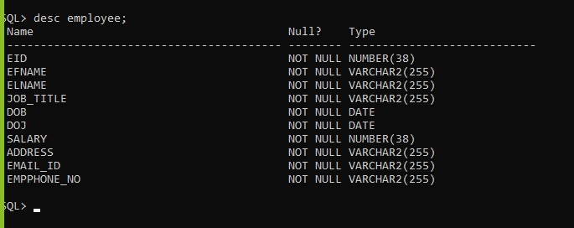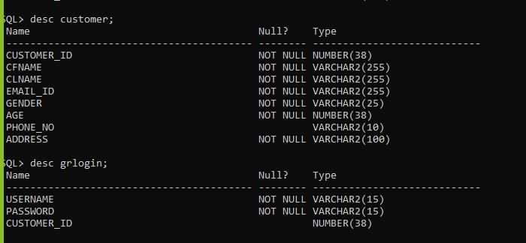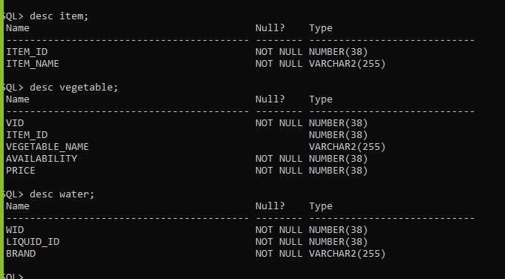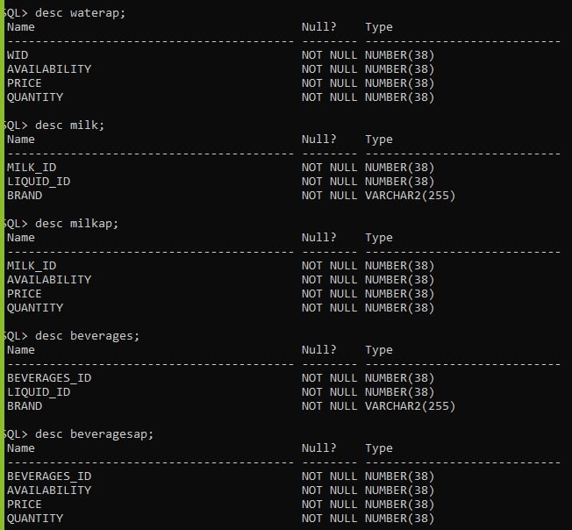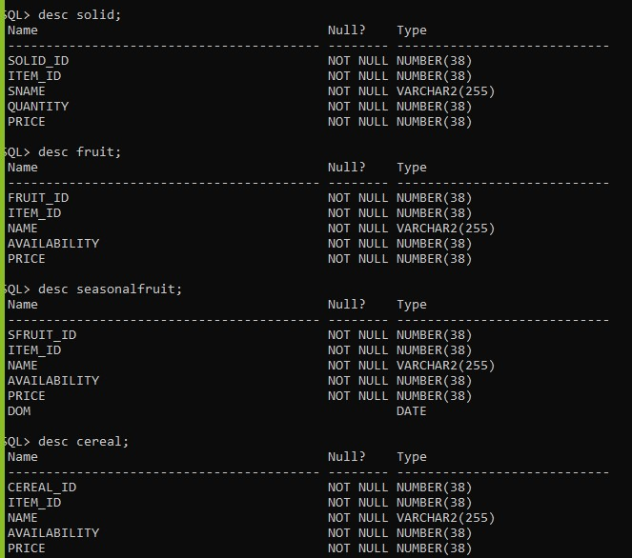

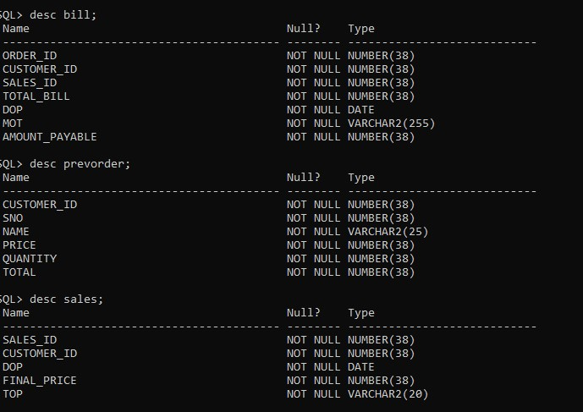

## SCREENSHOTS

**Admin:**

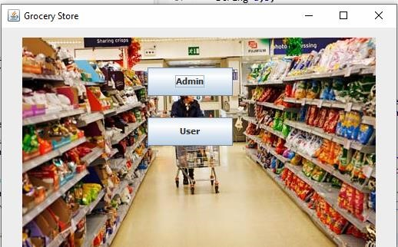

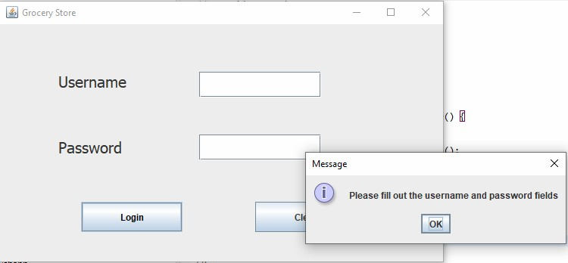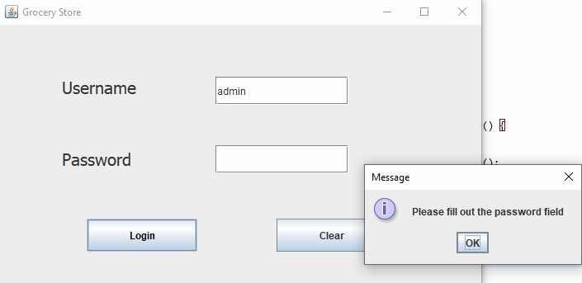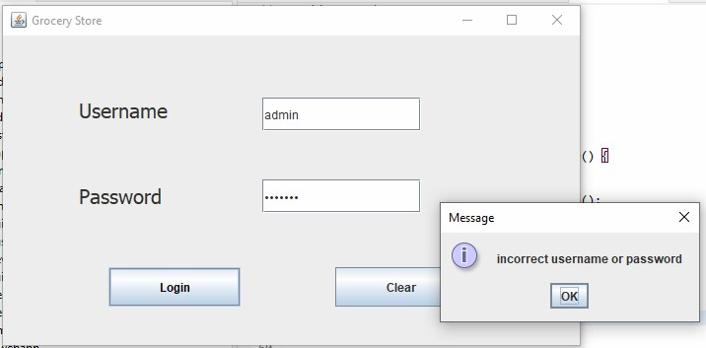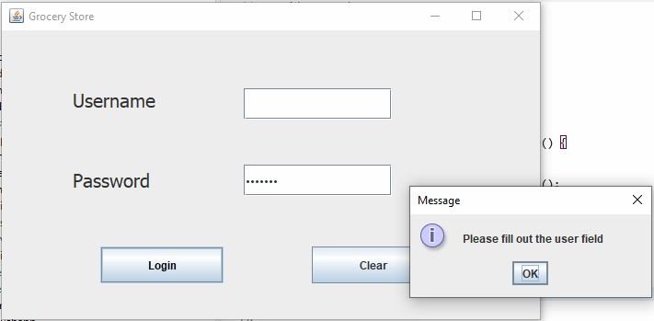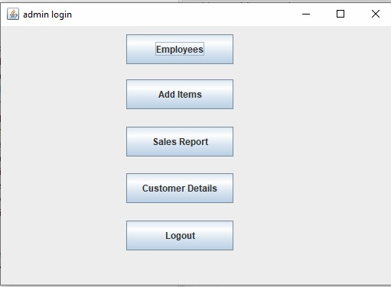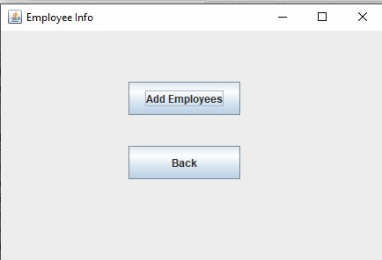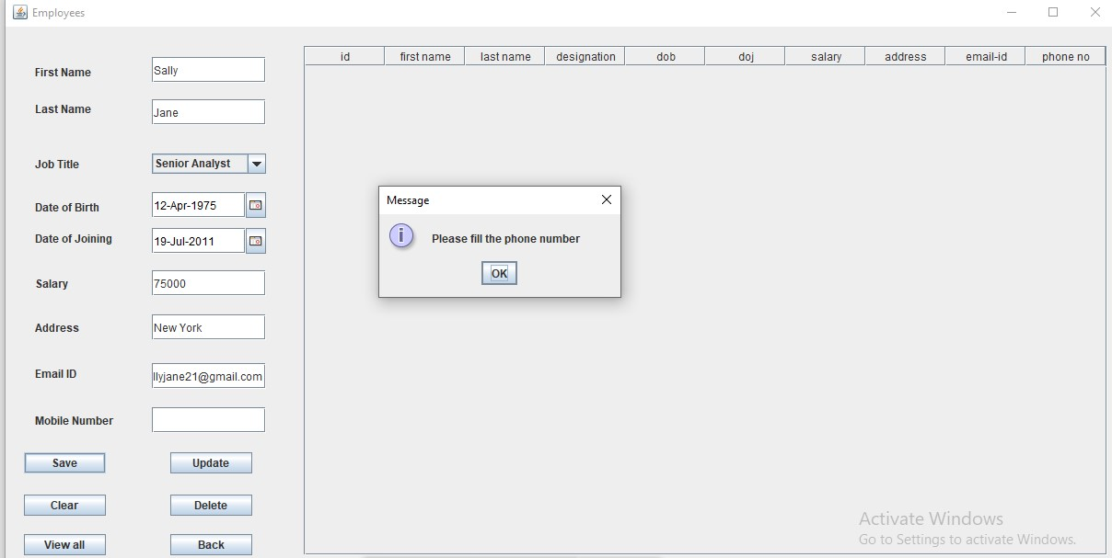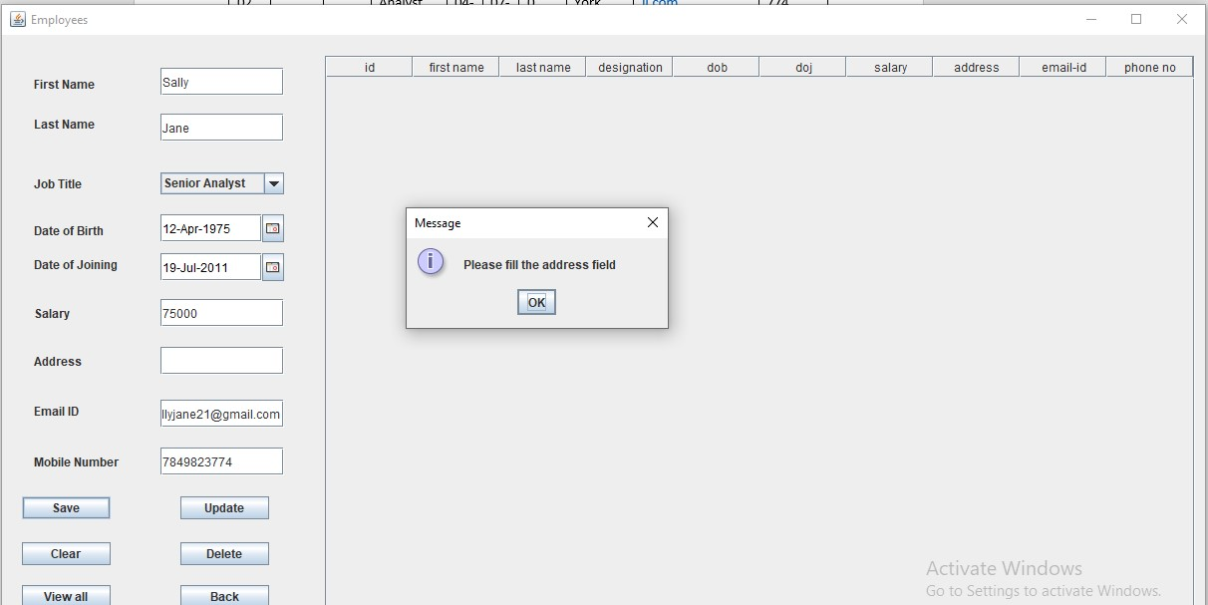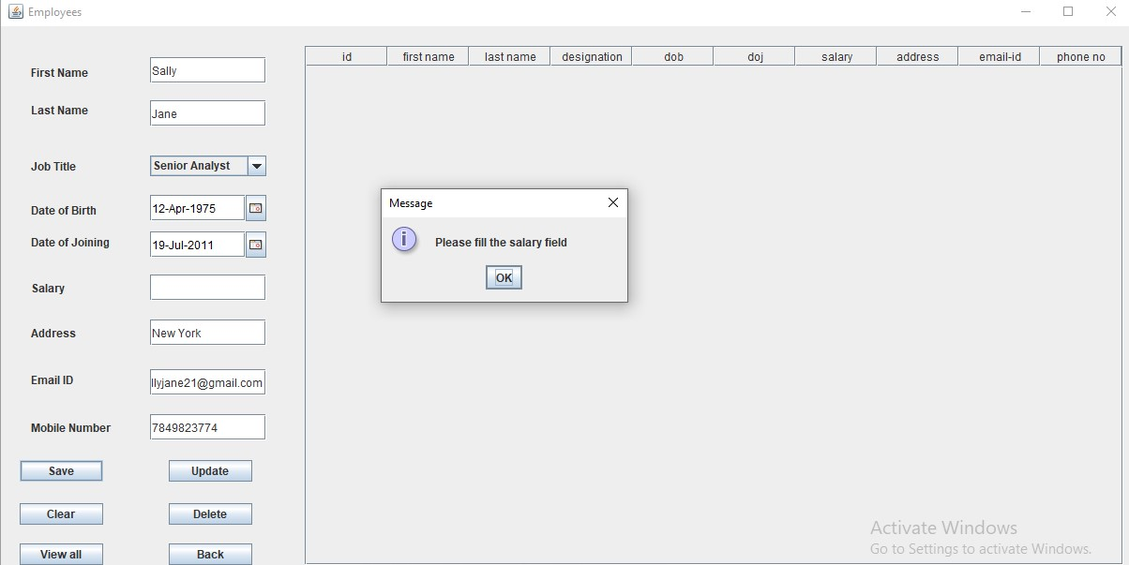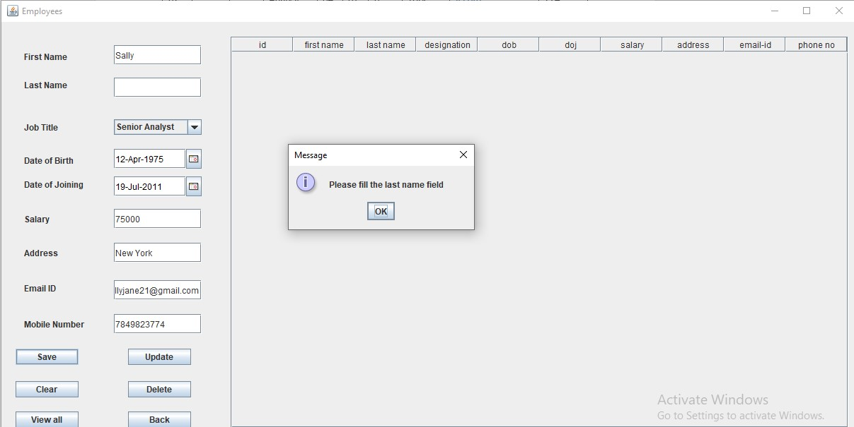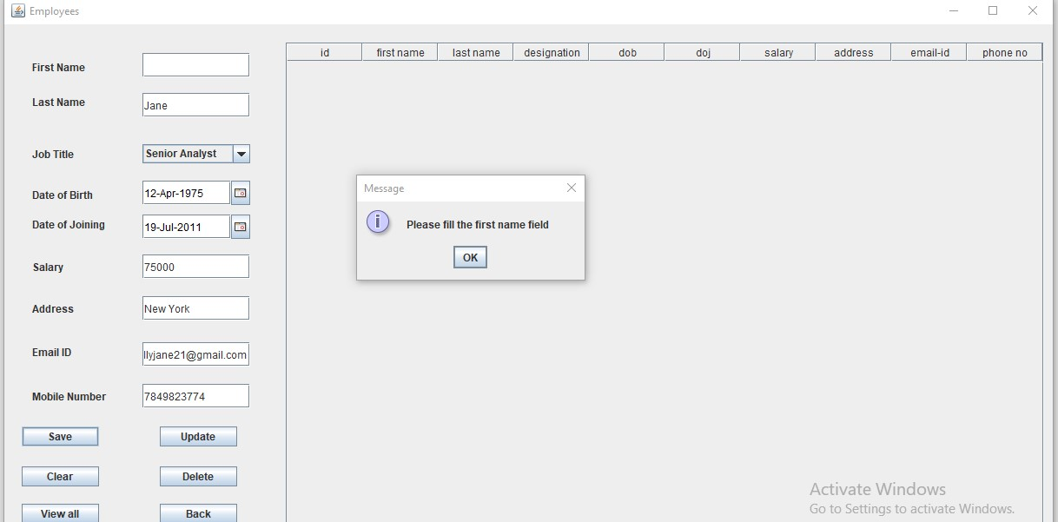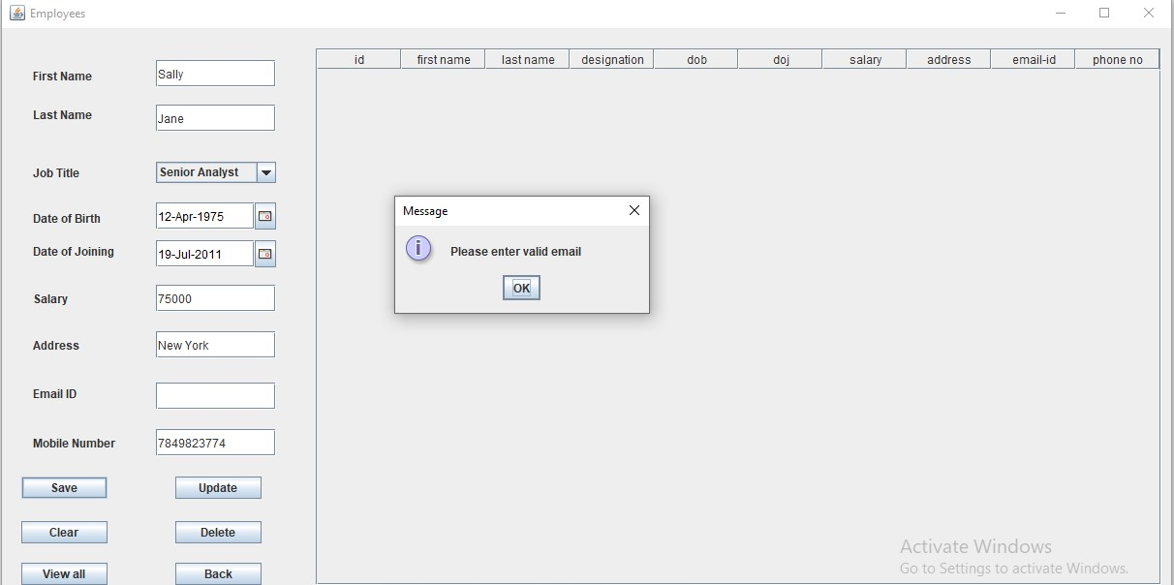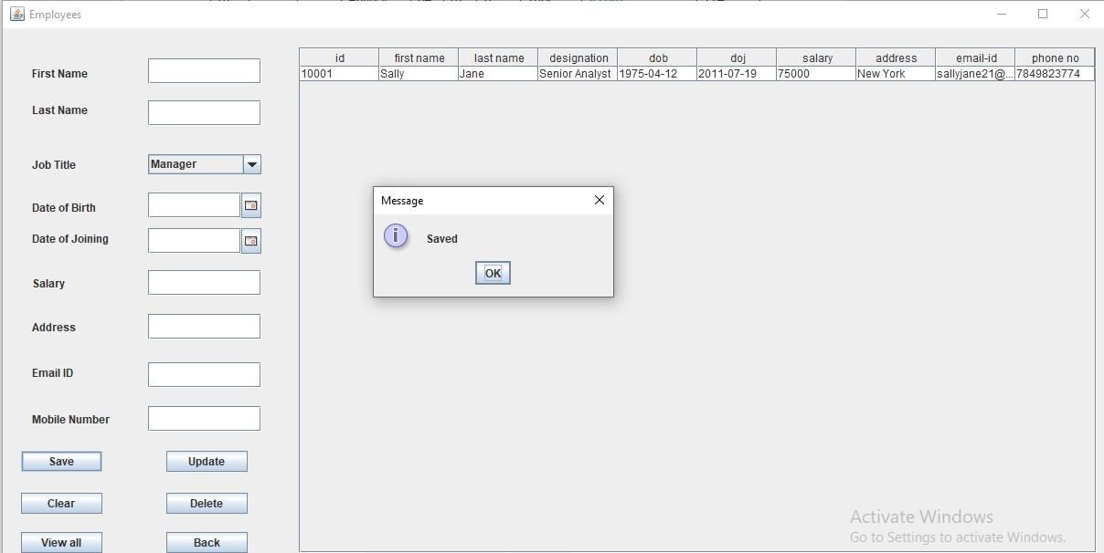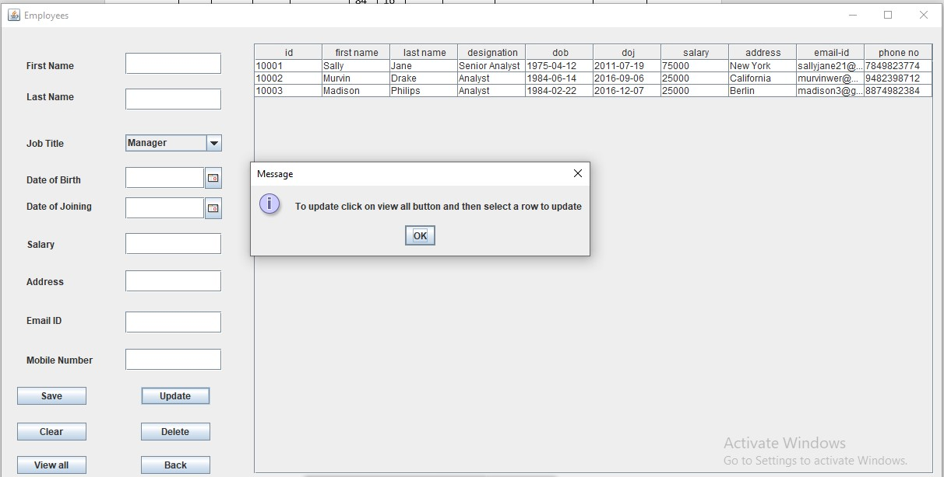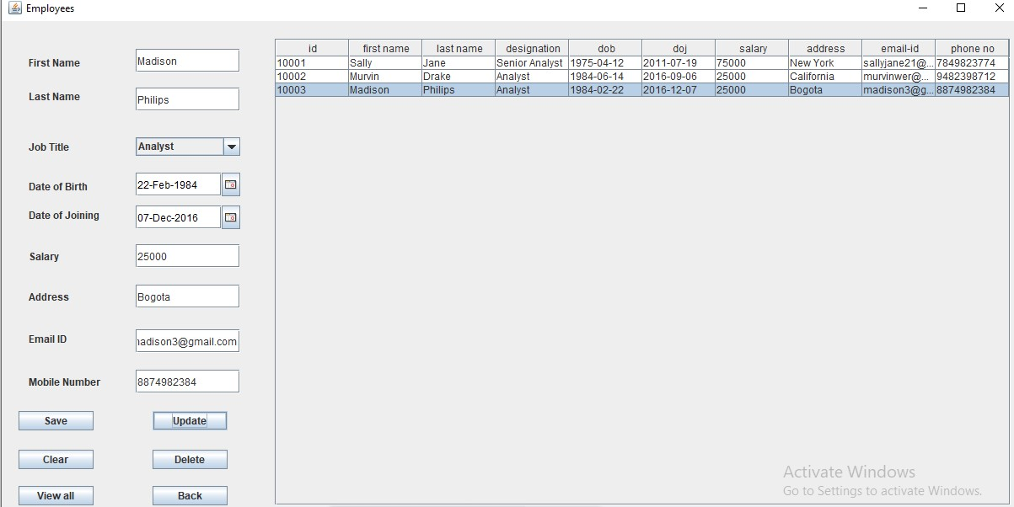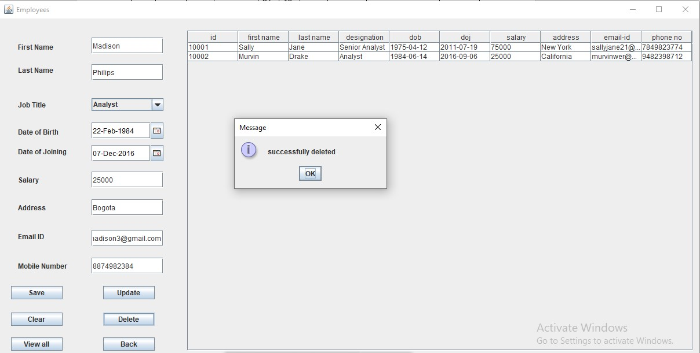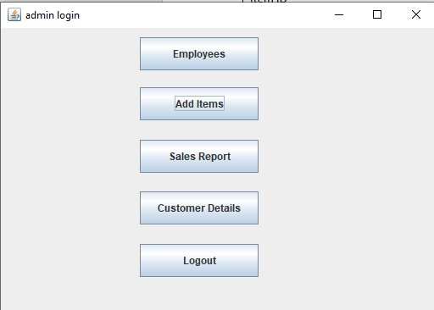

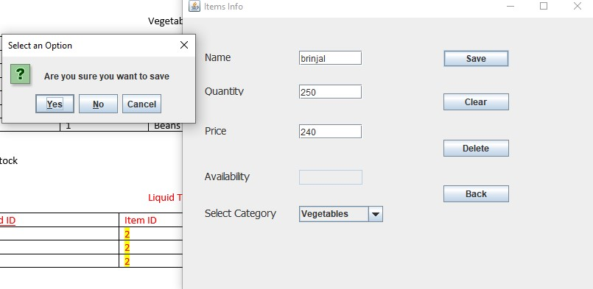

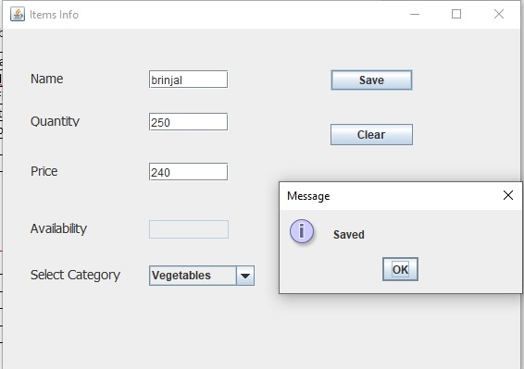

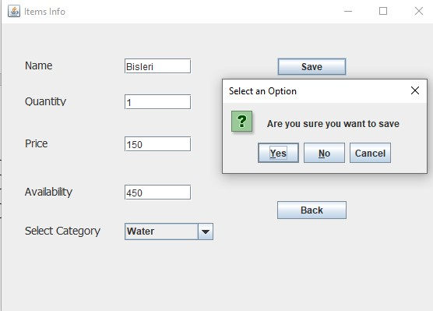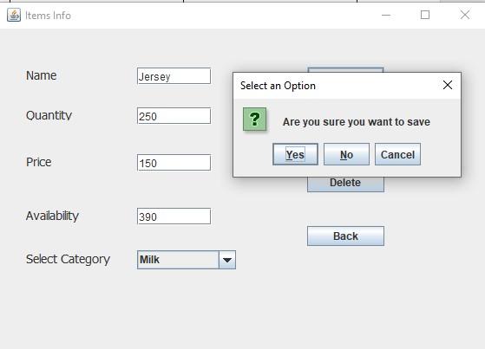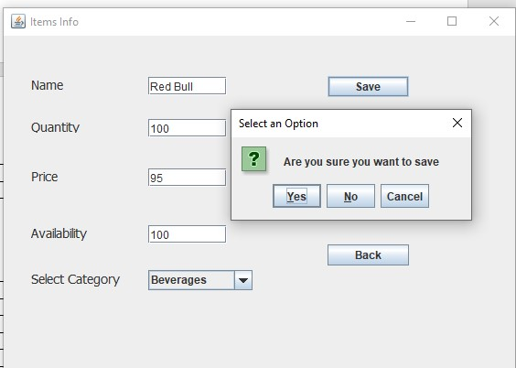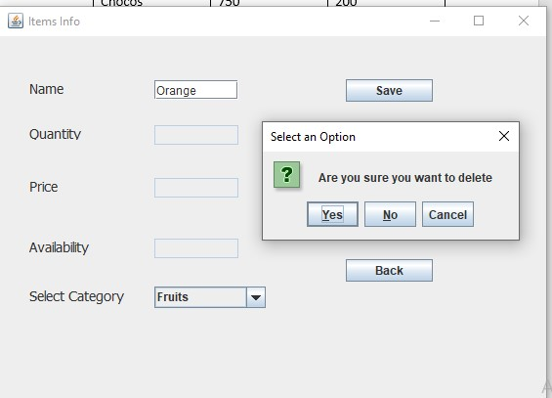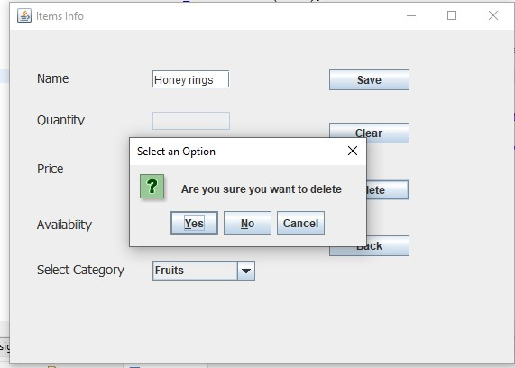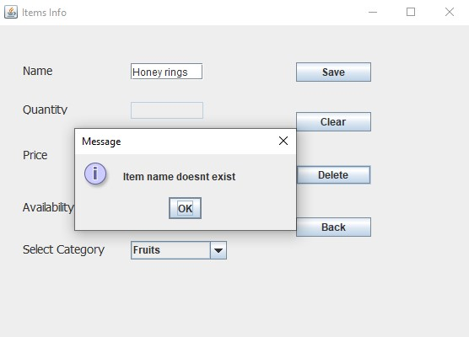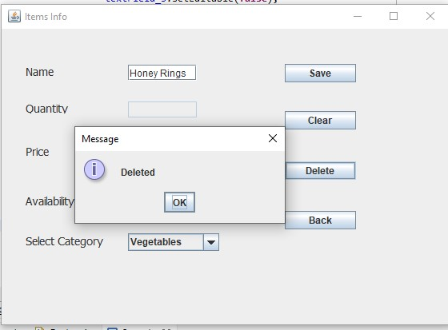

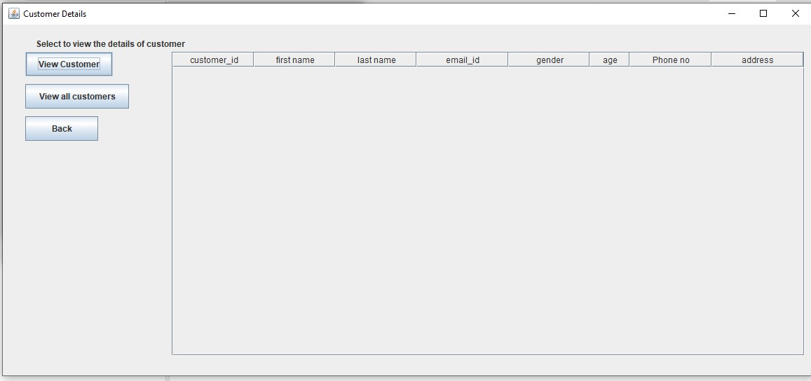

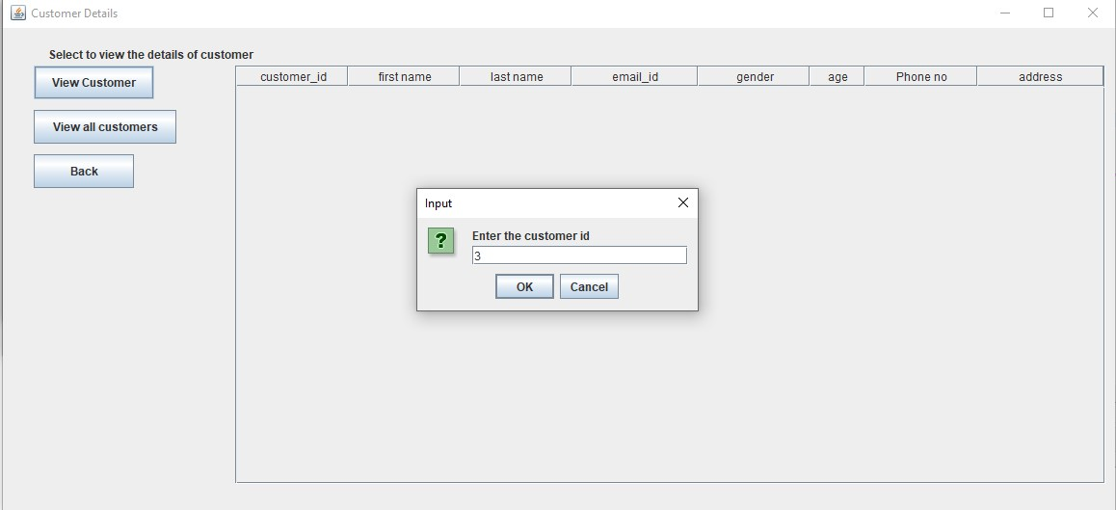

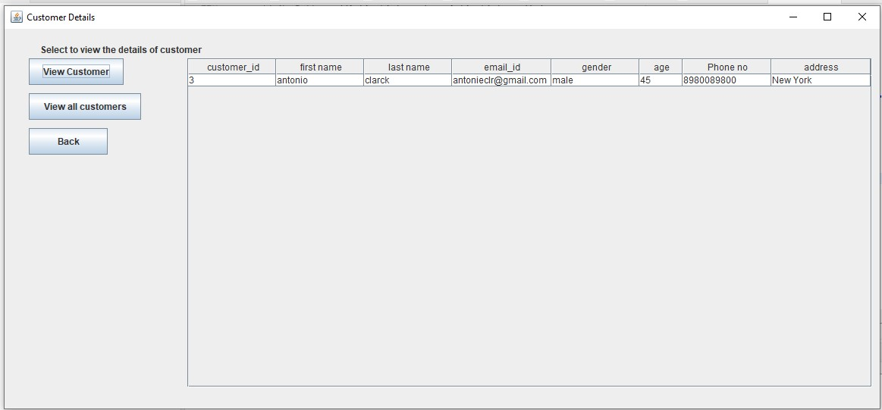

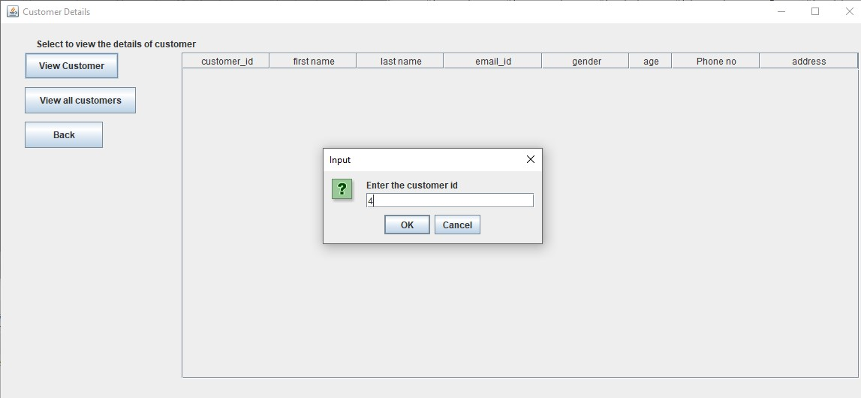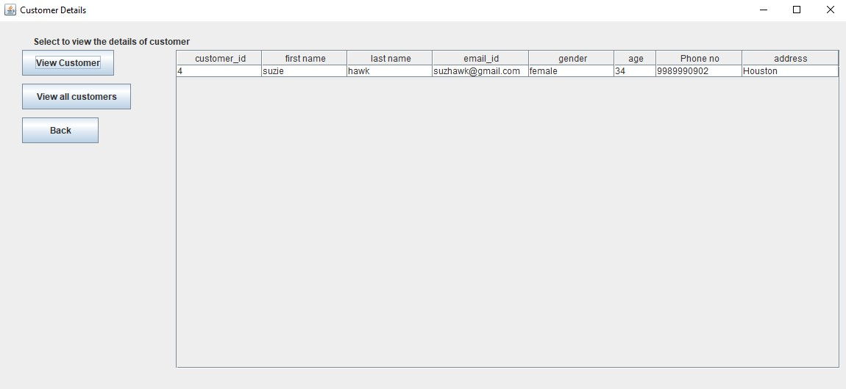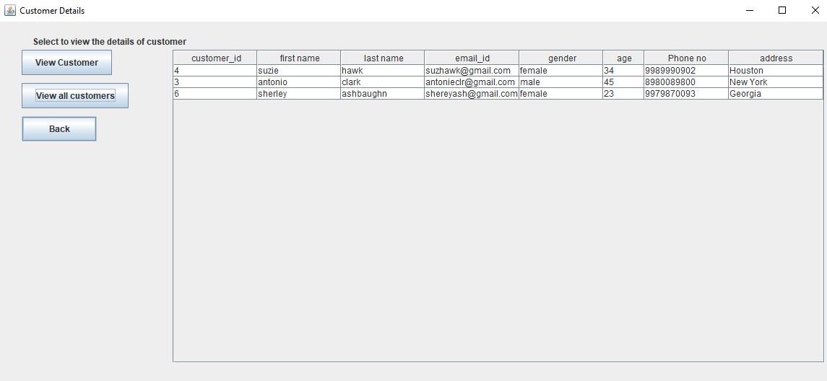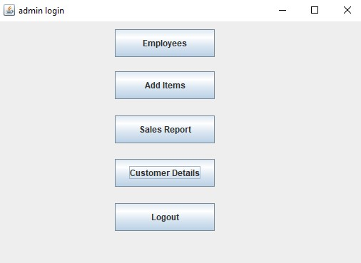

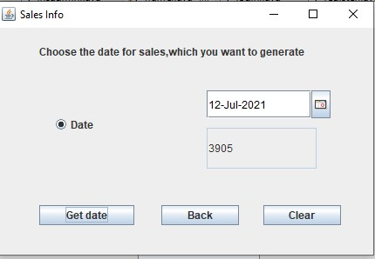

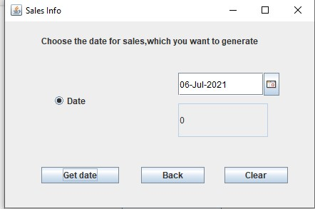

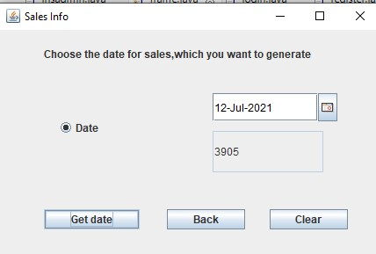



## User

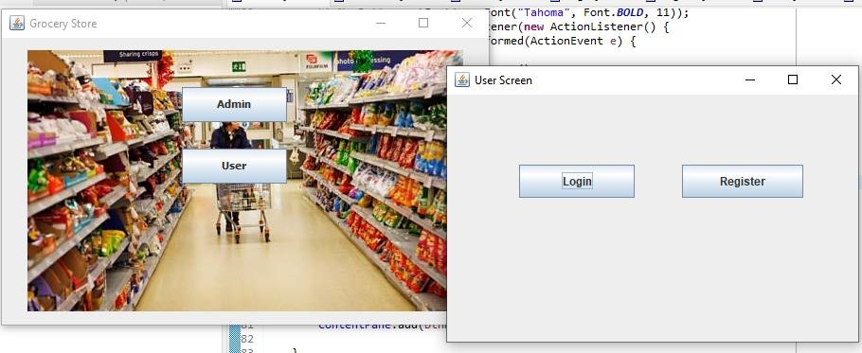

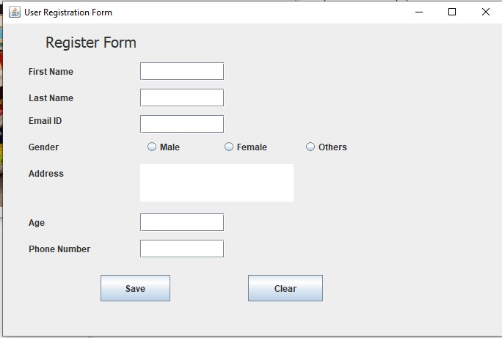

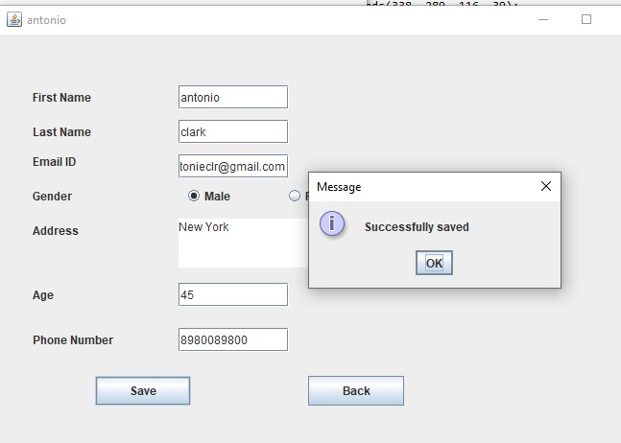

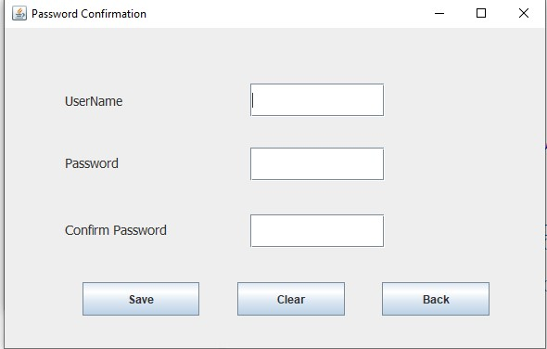

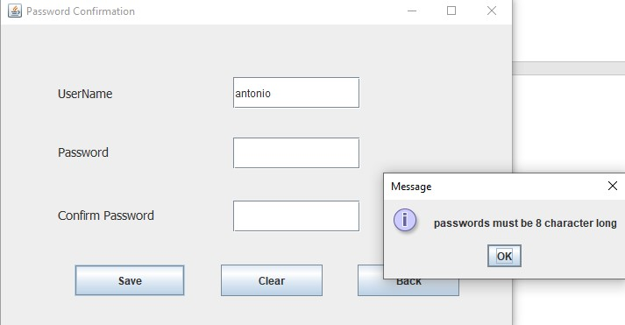

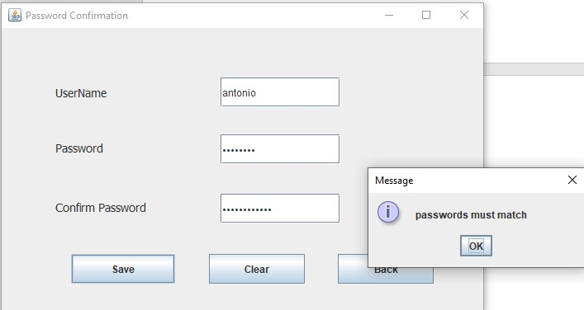

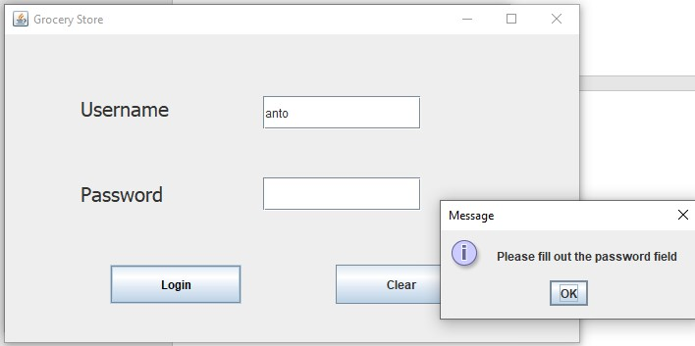

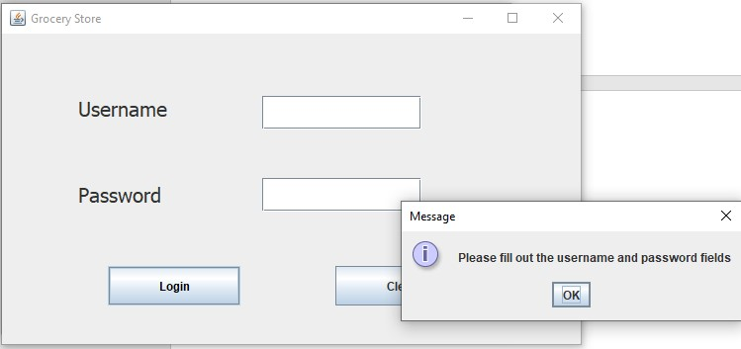

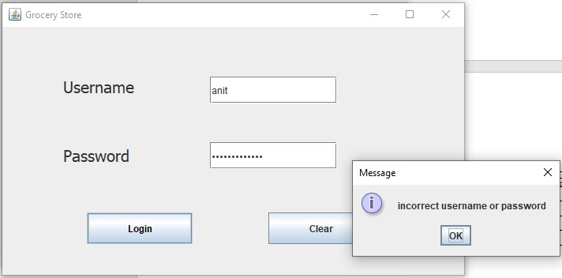

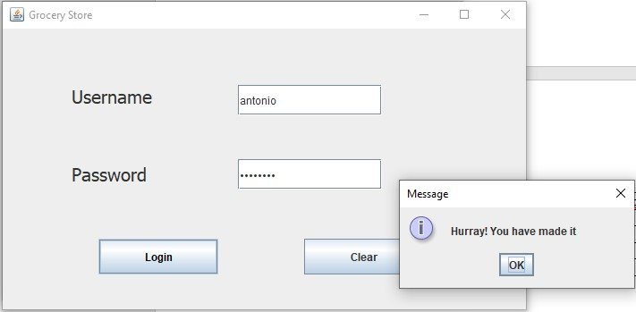

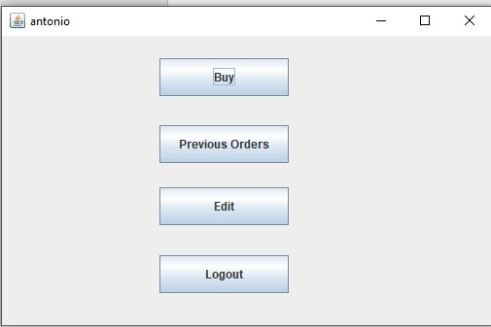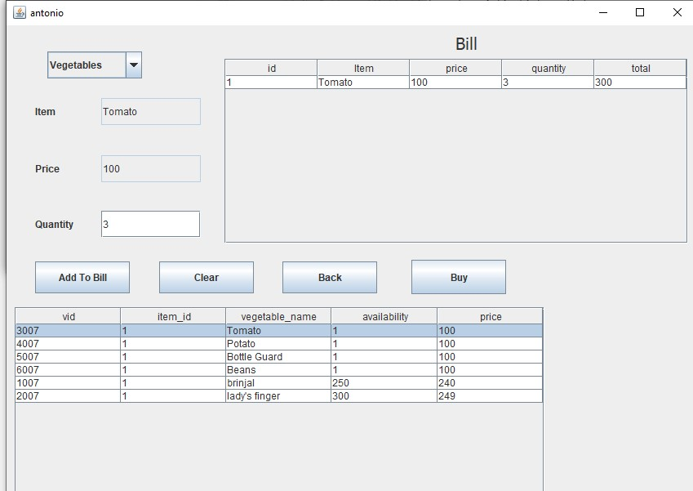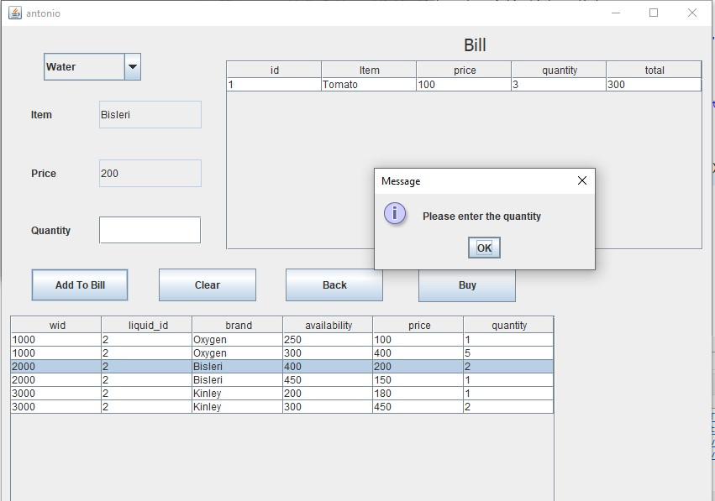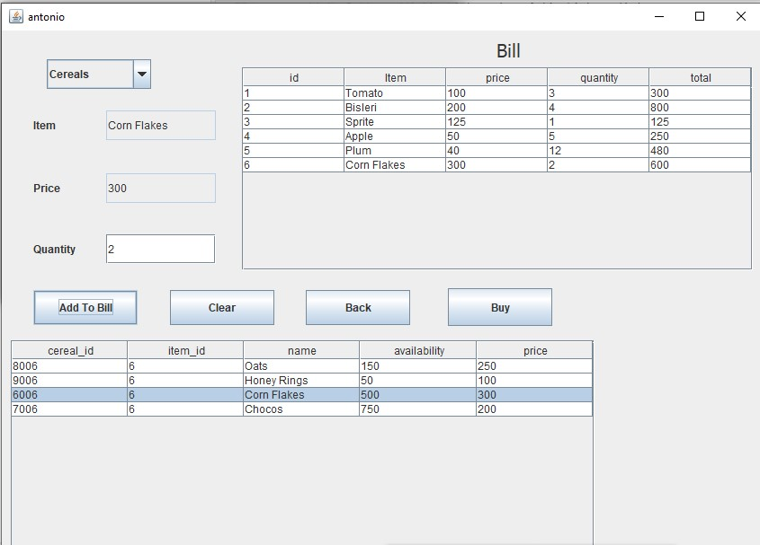

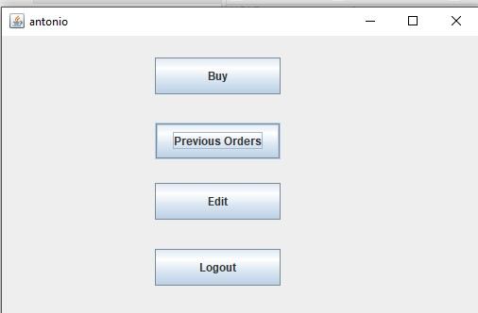

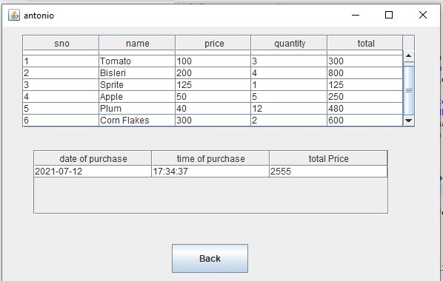

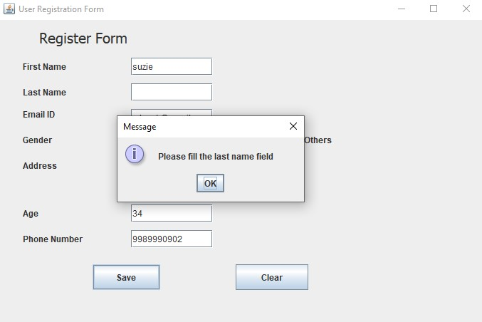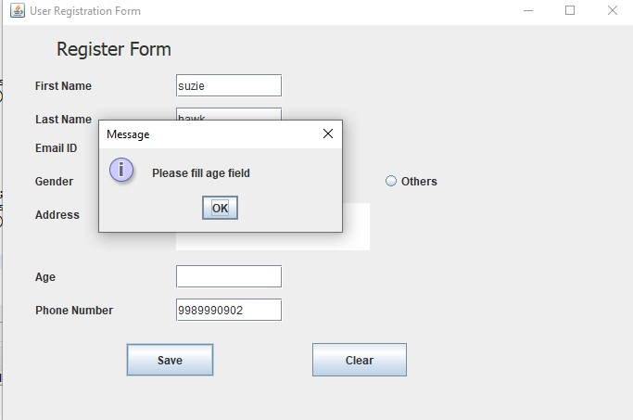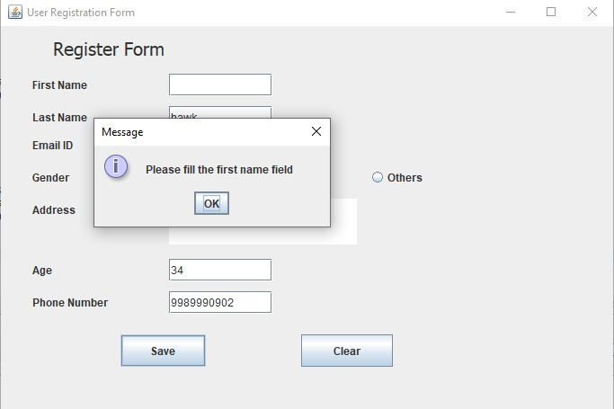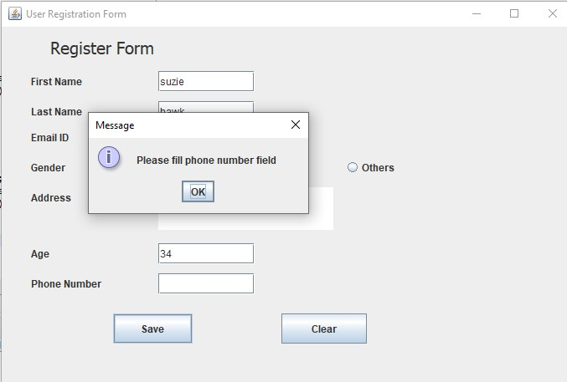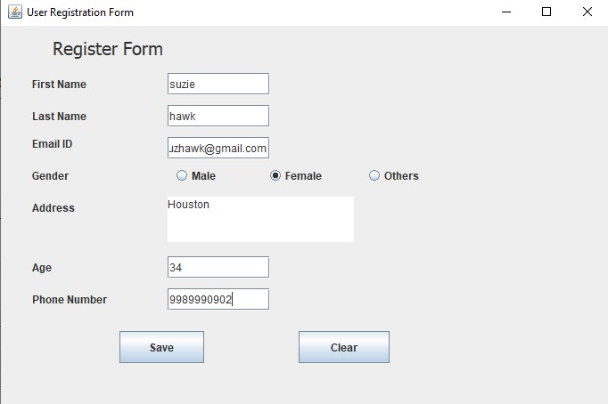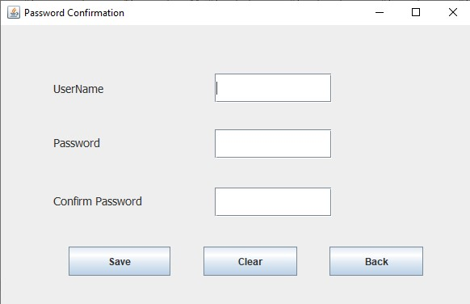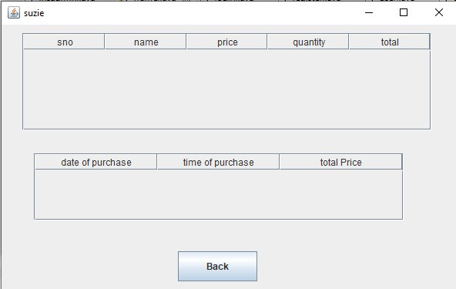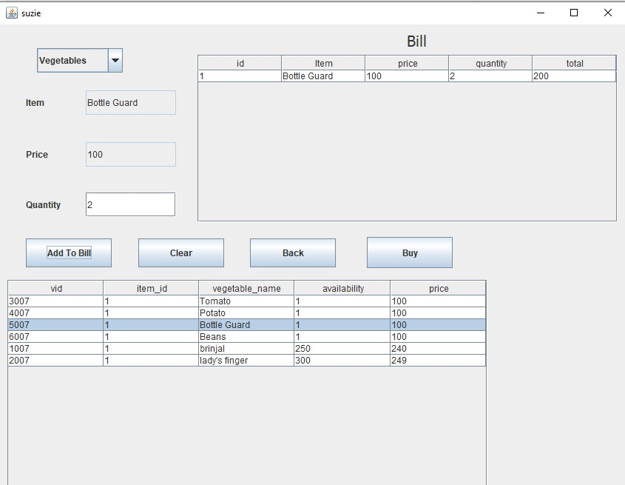

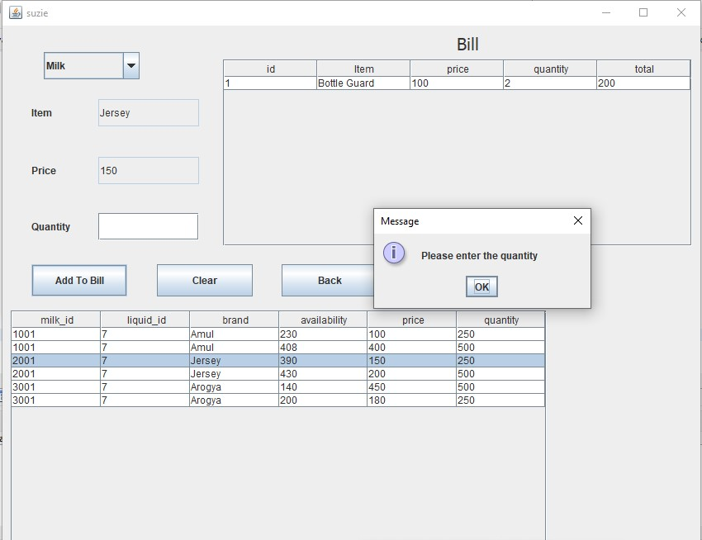

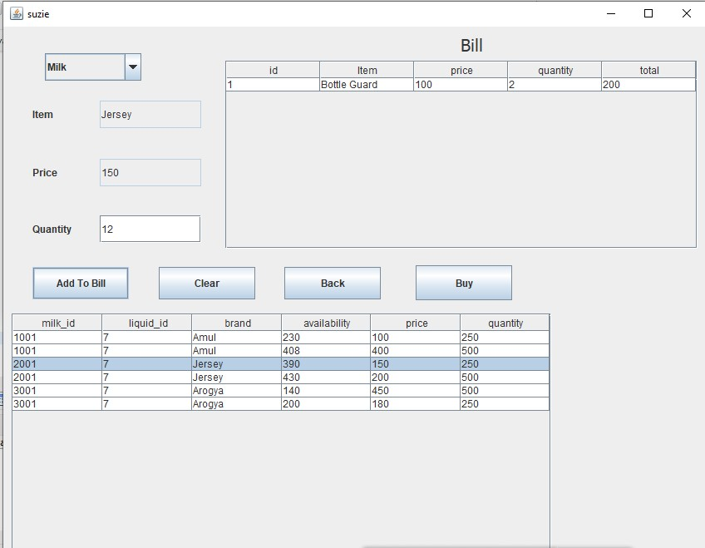

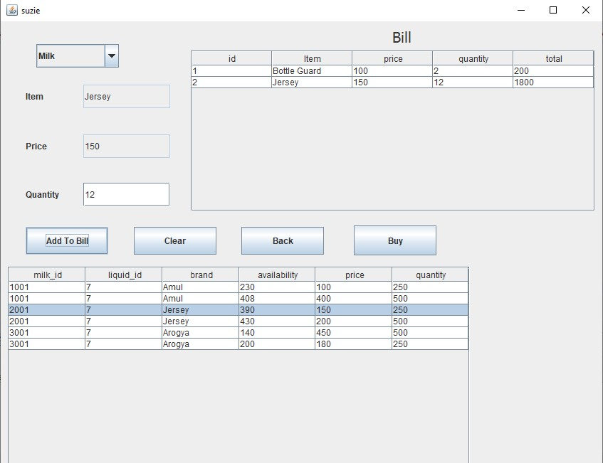

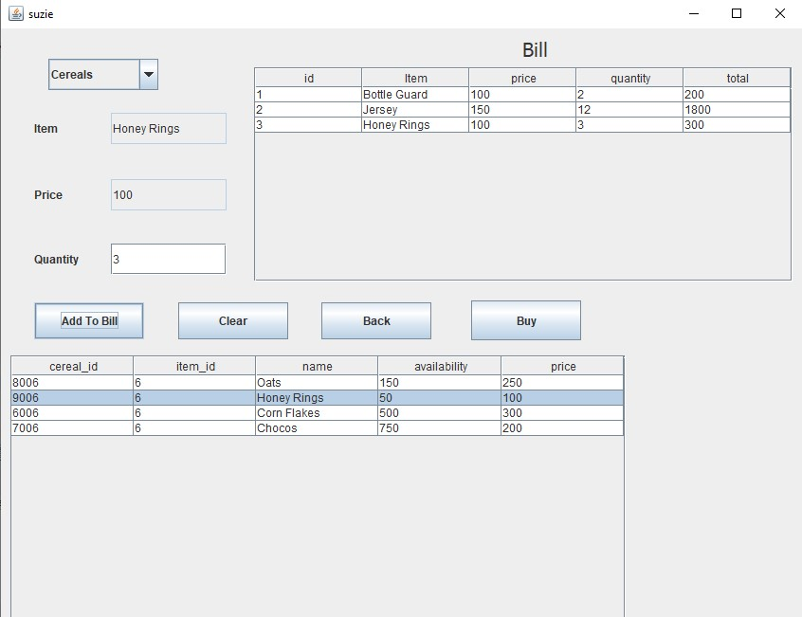

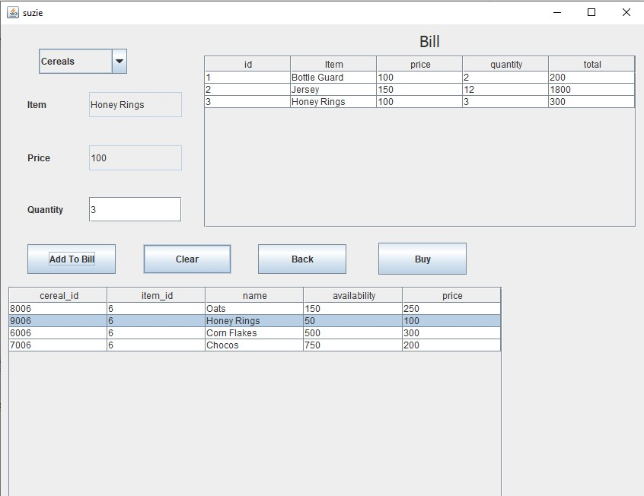

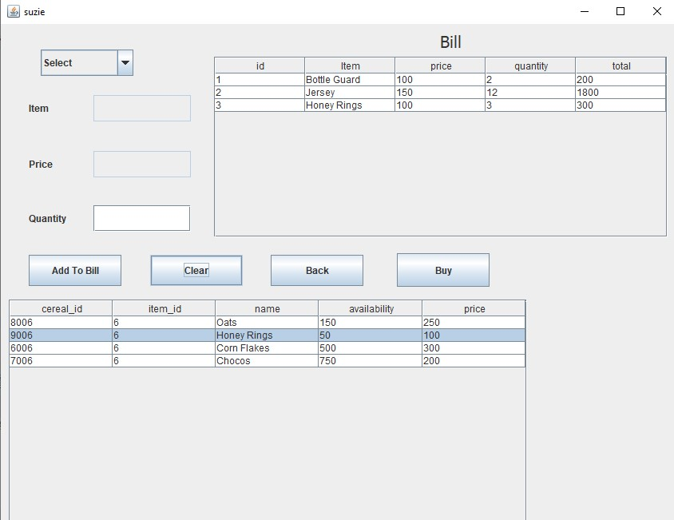

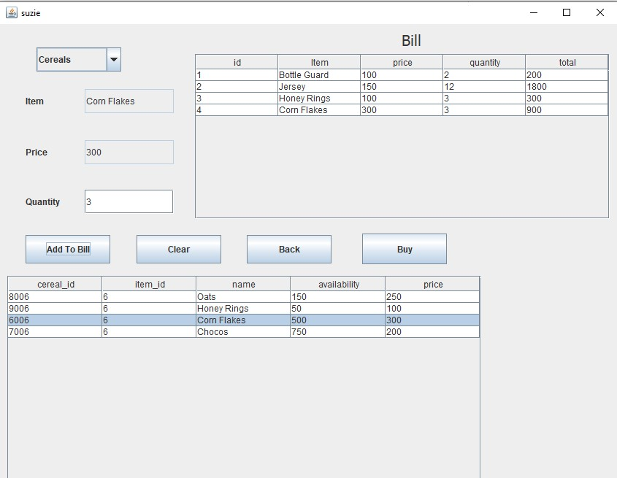

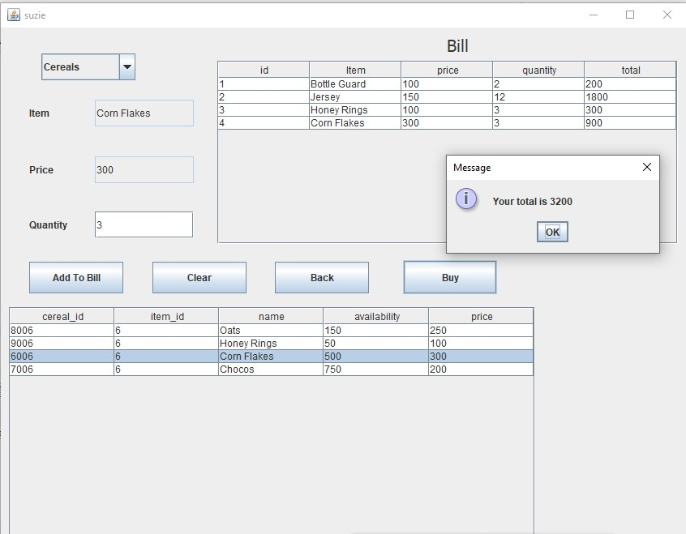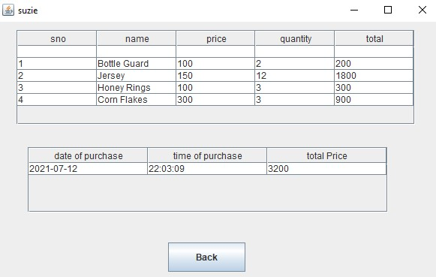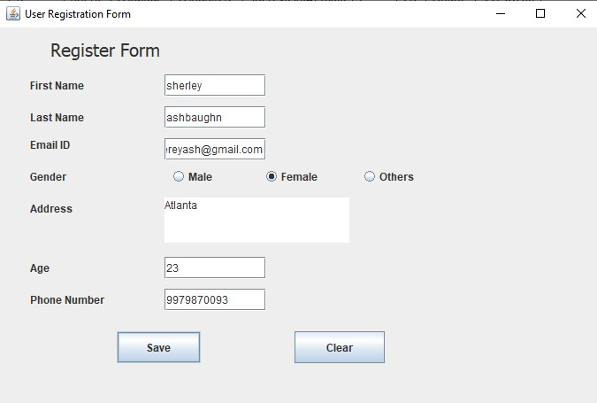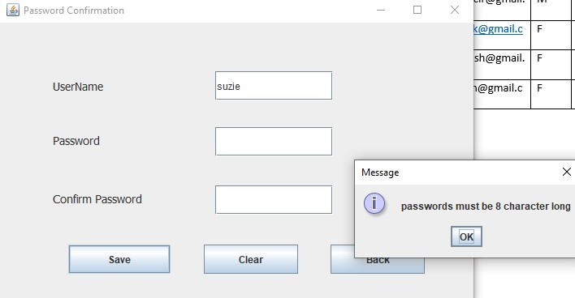

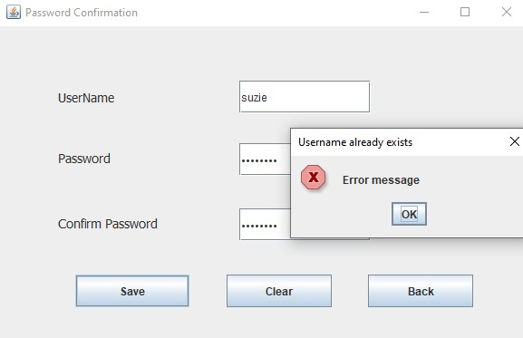

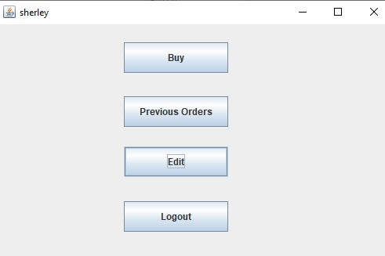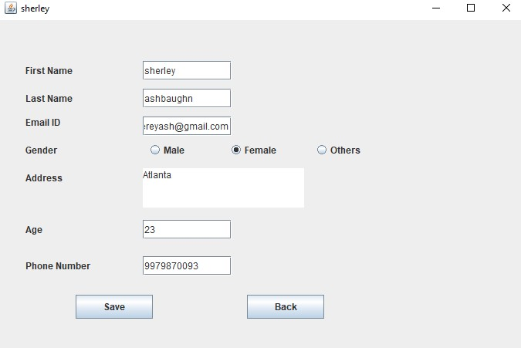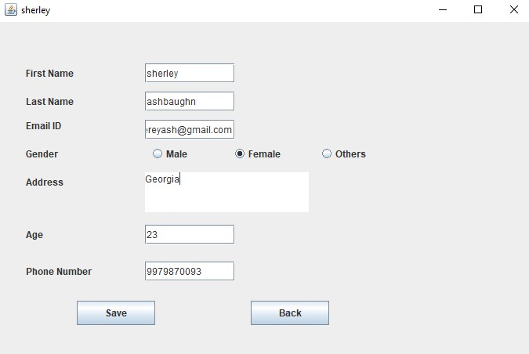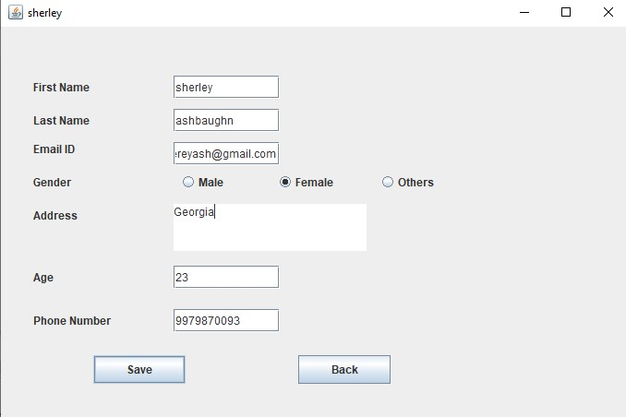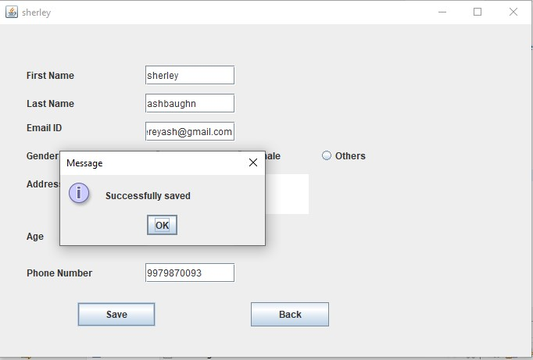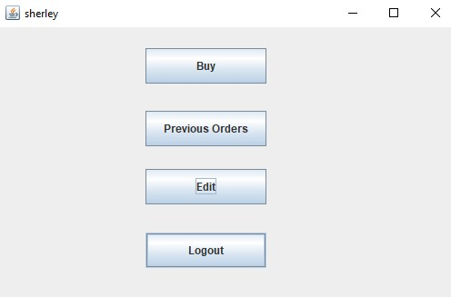

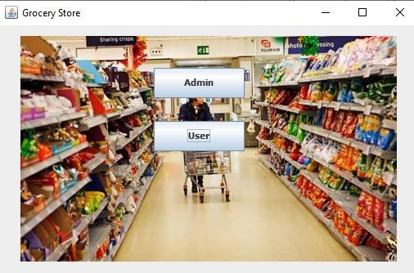

### Testing

The code written for building GUI and connecting with database ensures that the values entered by the user are of correct data types. It prompts an error message if the values entered are not of the specified data types.

### RESULT

1. Connection with database is established
2. The values given for tables in the GUI components by the user are saved in the database.

### REFERENCES

https://docs.oracle.com/javase/7/docs/api/

https://www.geeksforgeeks.org/establishing-jdbc-connection-in-java/ https://www.javatpoint.com/java-swing ww.stackoverflow.com www.tutorialride.com